AWGAN: A Powerful Batch Correction Model

Tianyu Liu1*,*#, Yuge Wang2*,*#, Hongyu Zhao2*,*∗

1 University of Illinois at Urbana-Champaign

2 Yale University

#: The authors contribute equally to this work.

*: To whom the correspondence should be addressed.

**With the advancement of technology, we can access large scale, high dimensional and diverse genomics data, especially through single-cell RNA sequencing (scRNA-seq). However, integrative downstream analysis from multiple scRNA-seq datasets remains challenging due to batch effects. This paper focuses on scRNA-seq data integration and proposes a new deep learning framework based on Wasserstein Generative Adversarial Network (WGAN) combined with an attention mechanism to eliminate the differences among cell batches. This paper also analyzes the shortcomings of previous studies and demonstrates the advantages of the new model from both theoretical and practical aspects, lifting the combination of deep learning and genomics research to a new level.**

# Introduction

The creation of single-cell sequencing data has a significant impact on the study of cell biology and cell genomics and has contributed significantly to the development of biology. However, the batch effect is an unavoidable problem when dealing with single-cell sequencing data [1–3]. The definition of batch effect refers to the difference in the distribution of single-cell RNA sequence for cells of the same tissue due to different objective factors (experimenter’s method of operation, working principle of experimental equipment, pre-processing method, etc.) with the effect of biological variation removed [4]. In addition, the removal of batch effect has important implications for multi-omics studies because researchers conducting downstream analysis need to distribute homogeneous large-scale data. Otherwise, they will have difficulty in carrying out subsequent work.

Before our model, many researchers have made remarkable progress in this area [5]. In general, there are two main ideas to remove batch effect. The first one is to assume that data from different batches obey the same type of distribution so that we can determine the parameters in the distribution and remove the possible noise in the dataset according to traditional statistical methods. The second one is to select one batch as a reference batch and others as query batches and get the corrected data by constructing a mapping from the queries batches to the reference batch. Representative models under the first strategy are Limma [6], Combat [7], Liger [8] and scVI [9]. The models represented by the second theory are Mutual Nearest Neighbor (MNN) [10], Seurat v3 [11], Batch balanced kNN (BBKNN) [12], iMAP [13], and Harmony [14].

Even with the many methods available, the task of batch correction still presents many difficulties. The most crucial point is to find a way to perfectly mix cells from the same cell type across different batches and to be able to discern batch-specific cell types [13]. The existing methods have different focuses on the above two points, but the different focuses of some methods can lead to bad results sometimes after batch effect removal (see our discussion part). Therefore, how to achieve a reasonable trade-off between the two is a challenge.

Moreover, the variety of single-cell datasets and the volume of data is increasing, so the task of researchers is becoming heavier. The classical method for batch effect removal usually adopts statistical inference strategies, which means we first assume that single-cell data follow a particular type of distribution and then estimate the distribution parameters (mean, variance,...). However, this kind of model cannot handle most cases in current research because the distribution of various single-cell data can be different. For example, we cannot assume that the scRNA-seq data of liver cells and blood cells follow the same distribution because the biological representations of the two tissues are very different. In addition, the expansion of data makes it take longer to predict the model’s parameters, and it is challenging to produce algorithms that optimize time complexity. In total, traditional statistical models are currently facing severe challenges. Therefore, researchers are paying attention to the machine learning models based on approximation theory, where the distribution of input data can be arbitrary [15]. However, several advanced models with machine learning strategies also have plenty of problems. Firstly, the existing machine learning-based correction models are poorly generalized, with imbalanced results on different datasets. Secondly, there is a risk of collapse in machine learning models related to the acquisition of datasets, processing, and the choice of model structure (We will discuss this part in this paper). We cannot eliminate this risk, but we need to make sure the probability of collapse is as low as possible. Finally, machine learning-based models tend to consume more resources and take longer to train [16].

These problems are bottleneck problems in the design of the batch effect removal model. Nevertheless, it is promising that AWGAN in this paper solves the bottleneck problems in machine learning models to a certain extent. This model has a lighter structure, a relatively shorter training time (using a combination of hardware and software acceleration), and better stability and generalization. In the results and discussion parts, we will illustrate this opinion.

# Results

## Overview of AWGAN

The workflow of AWGAN can be summarized as three key steps: attention-driven data preprocessing, AWGAN training and model evaluation (figure 1):

a

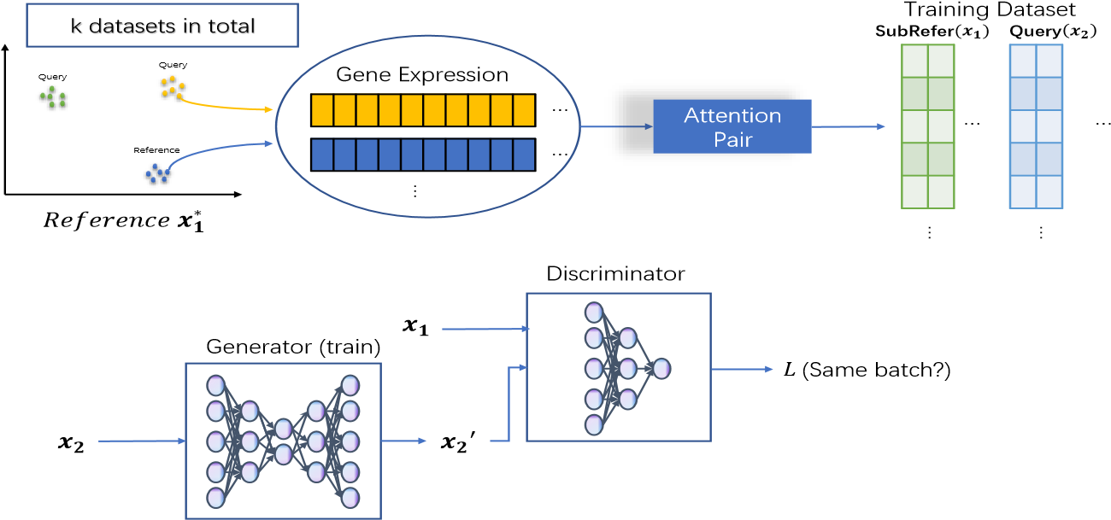

b

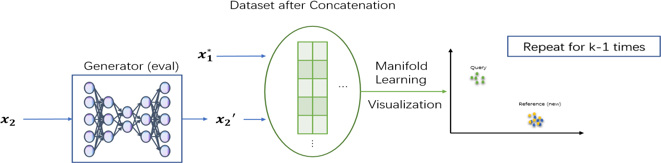

Figure 1: Working Flowchart. (a) This framework represents the process for AWGAN training steps. The attention pair will be transferred in to gene expression data and fed into the model. (b) The downstream process for the AWGAN model. The result received from the generator will be utilized for further work shown in Results and Discussion.

In the first step, highly variable genes are selected across batches as common features for data integration. Moreover, the dataset cannot be directly fed into the training model because we need to ensure that our method can preserve the biological information. Therefore, the number of cells in training datasets can be compatible as #(*SubReferData*) = #(*QueryData*). In this paper, inspired by the attention mechanism in the nature language processing scheme [17], we utilize a similar attention mechanism that can be used to generate a subset of reference data matched to the query data by selecting nearest neighbor pairs (see Methods). For the condition of two batches, we only need to train the model once. However, if there are k (k *>* 2) batches in the target dataset, we choose to utilize incremental matching learning strategy by running the attention algorithm and the model training process for k − 1 times. After each round, one query dataset will be integrated into the total reference batch, making the reference batch become larger and larger. Since training GAN is very tricky and requires the two distribution samples as similar as possible [18], utilizing sequencing training is significant.

In the second step, after we generating the training dataset, we utilize the WGAN [19] with gradient penalty [20] to generate a map that can transfer the query data into data with a distribution similar to the reference data. In addition, to reduce the possibility of model collapse, we also allow the self-adaptive mechanism in finding suitable regularization coefficients for the gradient penalty and making adjustment for the number of training epochs. WGAN is composed of one generator model and one discriminator model. The former model is used to generate data that follow a new distribution from the query data, while the latter model is used to discriminate whether the corrected query data have a similar distribution with the reference data. Moreover, the discriminator can find batch specific cell types and maintain their property. We adopt a strategy of confrontation training to improve the ability of the two models and finally achieve the Nash equilibrium between them [21].

In the last step, we can generate an integrated scRNA-seq dataset after removing the batch effect. To visualize the results, we prefer UMAP [22] as a manifold learning choice. Moreover, to quantify the results after removing batch effect, we consider four metrics: ASW [23], kBET [24], LISI [14] and Graph Connectivity [5] for quantitative evaluation in this paper.

## Small-scale scRNA-seq Datasets

We first evaluated our model against others on datasets with known cell type labels and normal data size (less than 30,000 cells), which can be used as a standard to compare the efficiency of different batch effect removal techniques. The datasets we chose in this part are listed as following: Pure Cell Lines (CL), Human Dendritic Cells (DC), Pancreas with removed certain cell types (Pancreas rm) and PBMC3&68K, mouse hematopoietic stem and progenitor cells (MHSP), Mouse Cell Atlas, and human peripheral blood mononuclear cell (Human PBMC). In order to better prove the superiority of our model, we provided two coordinate representations of two different metrics (ASW [23], and LISI [14]) for each dataset. We defined the task related to batch specific cell type discerning task as cell type optimization task and the task related to the mixing of common cells in different batches as batch optimization task. For cell type optimization task, we had casw and 1-clisi and higher values indicate better cell type separation. For batch optimization, we had 1-basw and blisi and higher values indicate a better mixing of cells from the same cell type across different batches. The visualization results based on UMAP and ASW/LISI map are shown in figure 2-5:

a

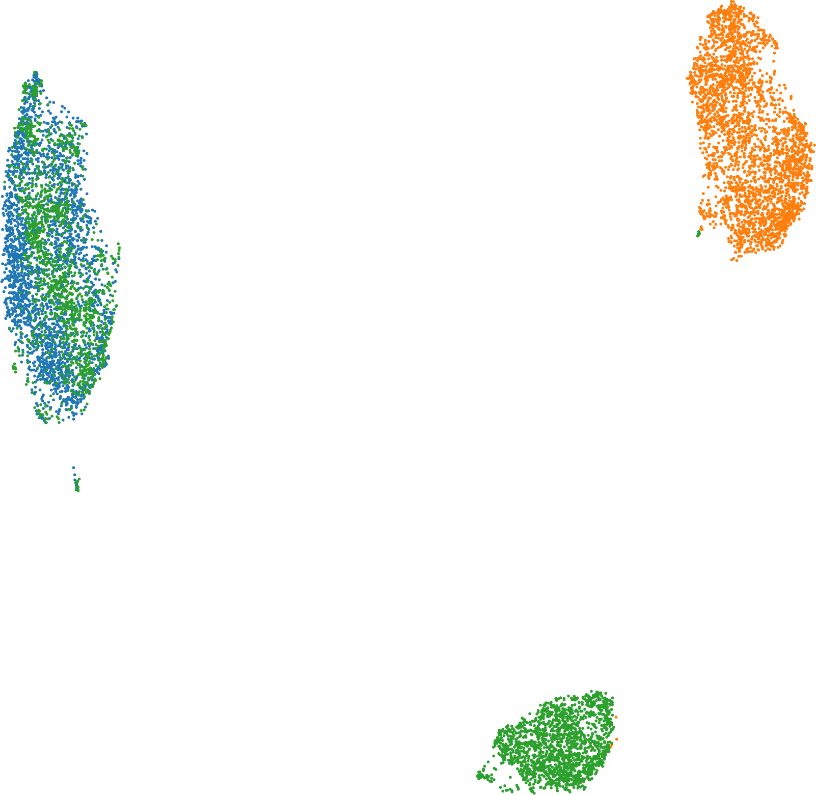

UMAP1

UMAP2

Batch1_293t

Batch2_Jurkat

Batch3_Mix

b

c

UMAP1

UMAP2

Batch1_293t

Batch2_Jurkat

Batch3_Mix

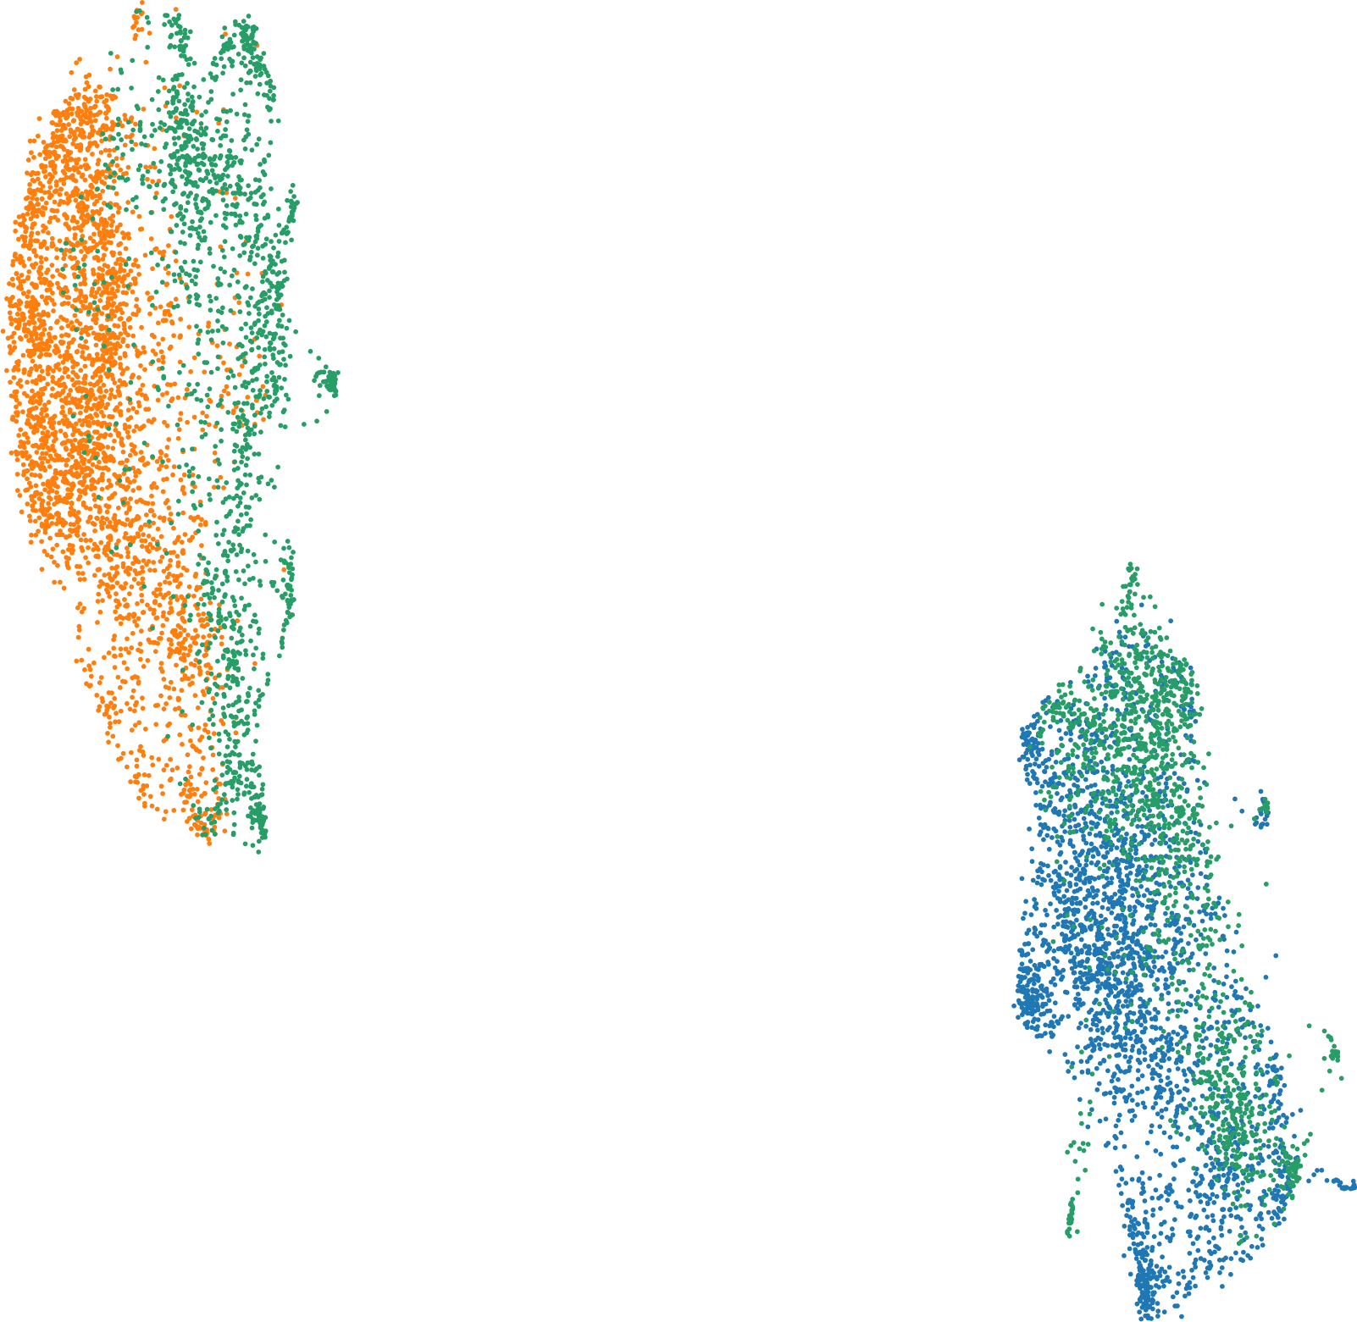

d

e

**raw**

**Seuratv3**

**iMAP**

**Harmony**

**scVI**

**Liger**

**AWGAN**

casw

0.50

0.55

0.60

0.65

0.70

0.75

0.80

ASW

**MNN**

f

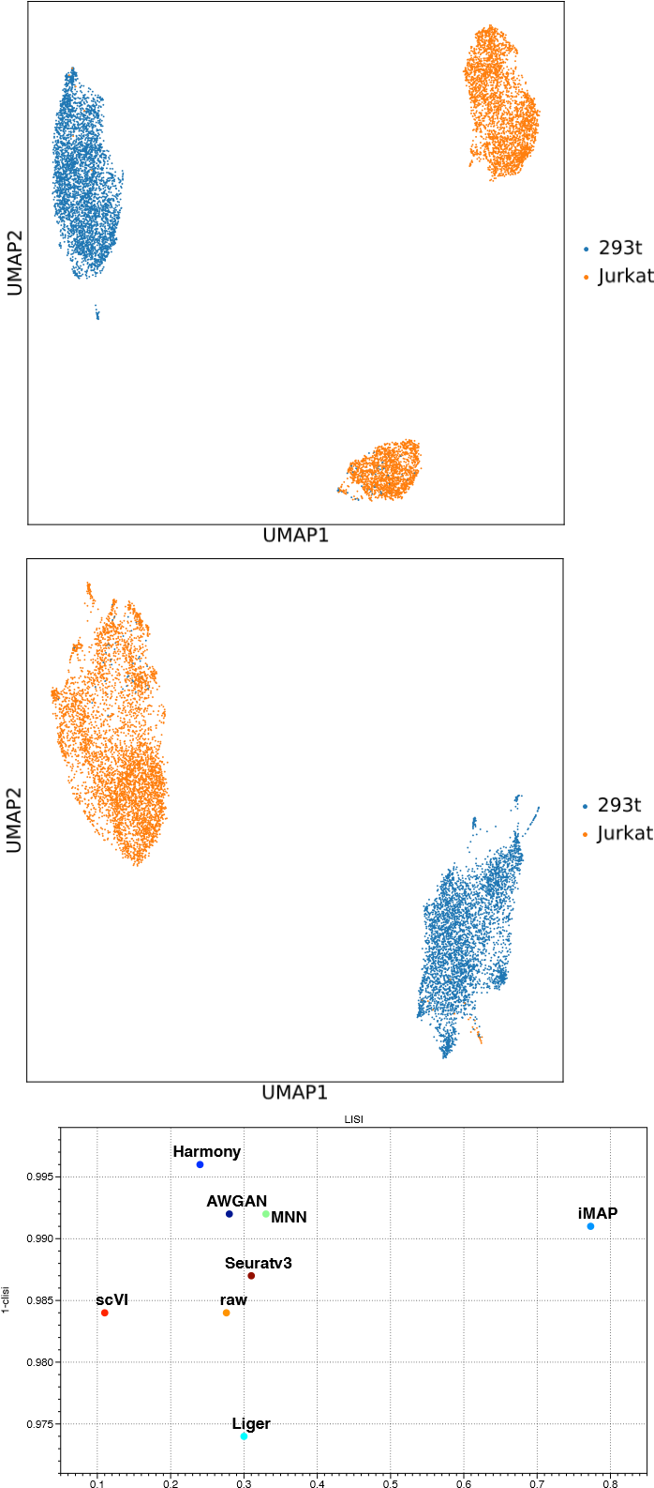

0.34 0.36 0.38 0.40 0.42 0.44 0.46 0.48 0.50 blisi

1-basw

Figure 2: CL dataset. (a) Visualization for the data distribution with batch label before batch effect removal. (b) Visualization for the data distribution with cell type label before batch effect removal. (c) Visualization for the data distribution with batch label after batch effect removal. (d) Visualization for the data distribution with cell type label after batch effect removal. (e) ASW assessments of different batch effect removal methods on CL dataset. (f) LISI assessments of different batch effect removal methods on CL dataset.

The CL dataset (figure 2) is composed of three different batches, including two pure batches “Jurkat” and “293T” containing Jurkat cells and 293T cells only and one batch “Mix” consisting of a 50-50 mixture of Jurkat and 293T cells. We can see from the results that the batch effect is eliminated for the three datasets, and the cells in Mix are mixed into the first two batches. The biological properties are also preserved, as cells in Mix are successfully mapped to their specified cell clusters. We can see that from figure 2 e, no method can surpass AWGAN in cell type optimization and batch optimization simultaneously. Comparing with other methods, like Liger, Seurat v3 and iMAP, AWGAN performs better than all of them in cell type optimization part according to figure 2 f, which means AWGAN has the most substantial ability to discern batch-specific cell types in this dataset. According to figure 2 e and f, only the performance of iMAP is much better than AWGAN in mixing cells in different batches, which proves that AWGAN also have relatively strong ability in this aspect.

a

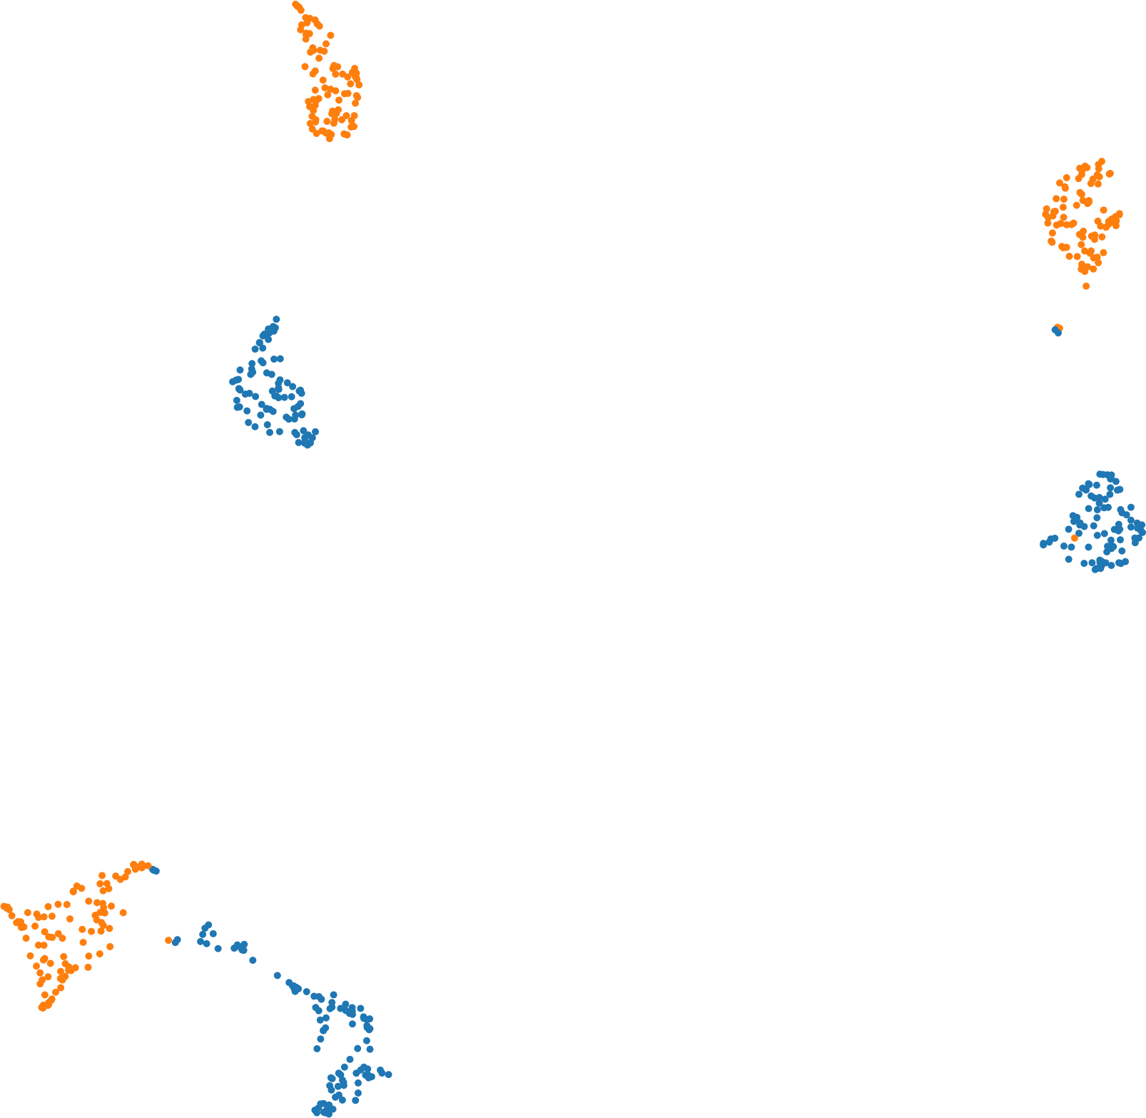

UMAP1

UMAP2

Batch1

Batch2

b

c

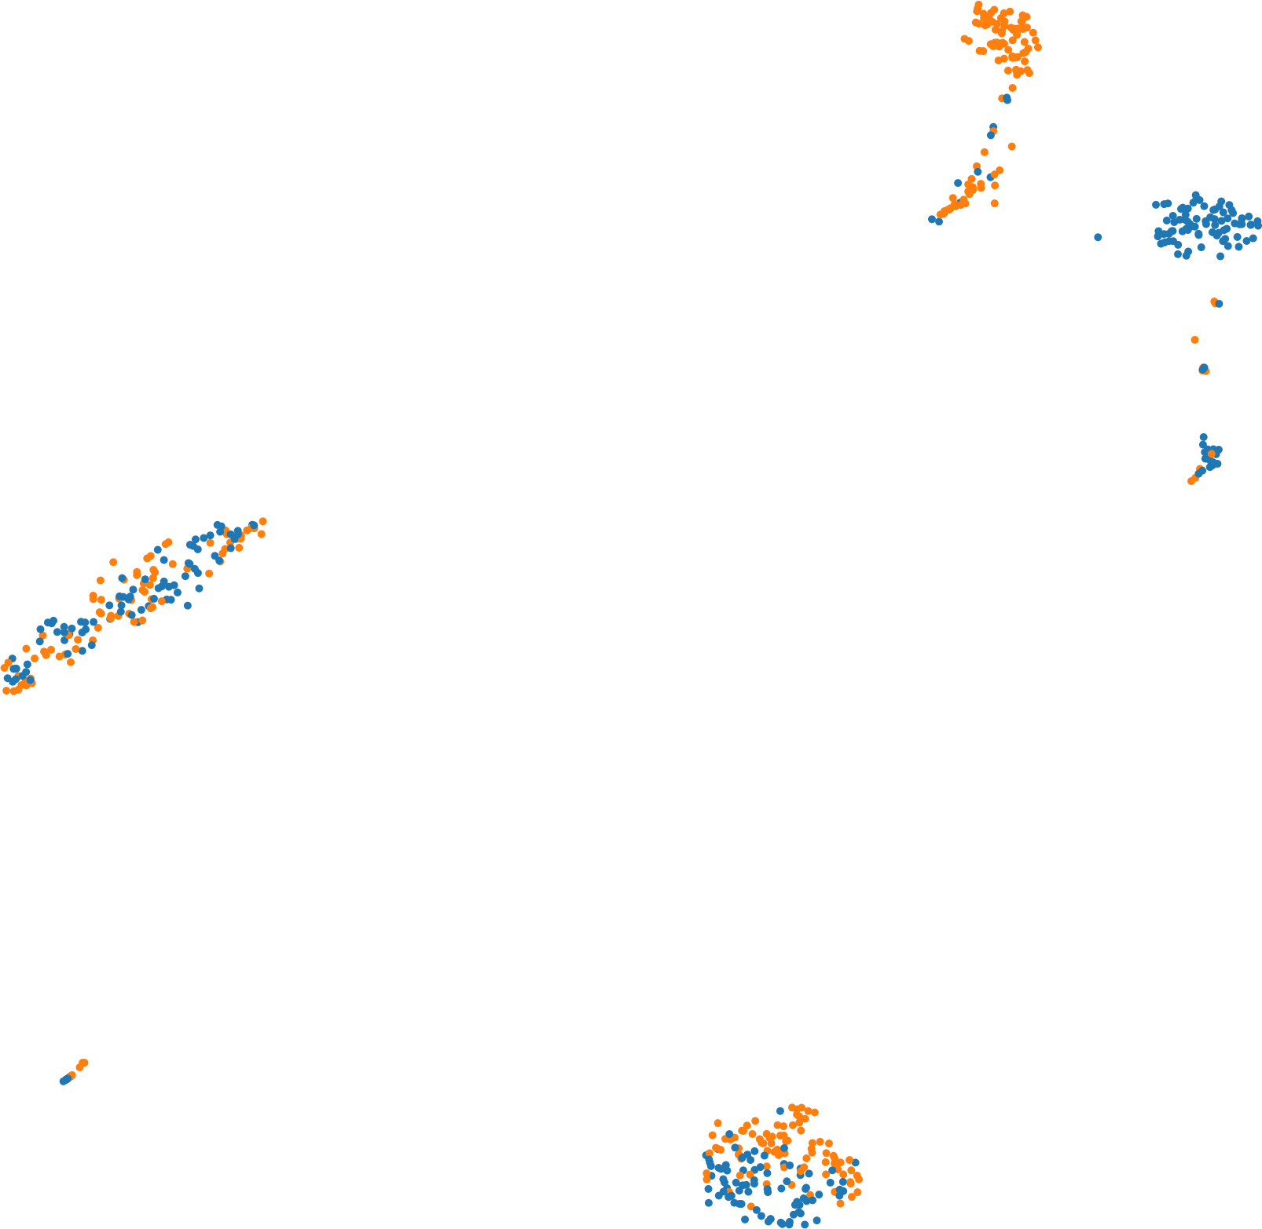

UMAP1

UMAP2

Batch1

Batch2

d

e

casw

0.52

0.54

0.56

0.58

0.60

0.62

0.64

0.66

0.68

0.70

0.72

0.74

ASW

**A**

**G**

**W**

**A**

**N**

**iMAP**

**S**

**e**

**u**

**r**

**a**

**t**

**v**

**3**

**Har**

**mon**

**y**

**s**

**c**

**VI**

**ra**

**w**

**Lige**

**r**

**MNN**

f

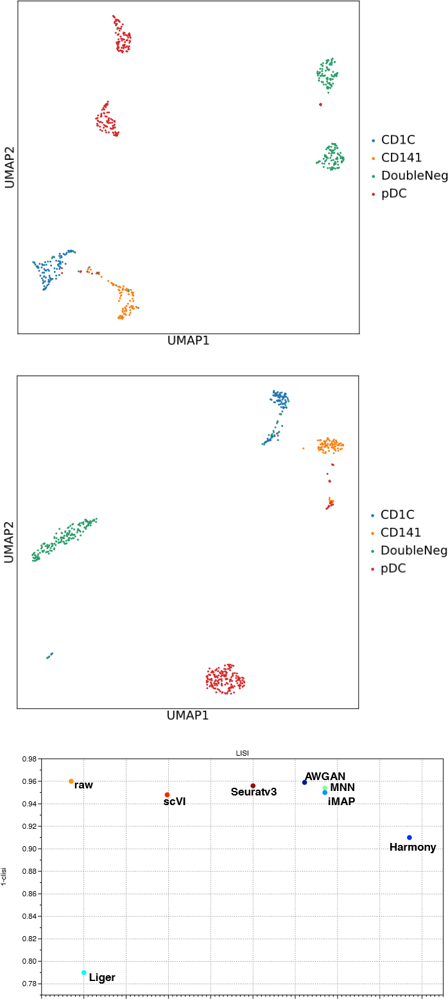

0.36 0.38 0.40 0.42 0.44 0.46 0.48 0.50 0 0.1 0.2 0.3 0.4 0.5 0.6 0.7 0.8 0.9

1-basw blisi

Figure 3: DC dataset. (a) Visualization for the data distribution with batch label before batch effect removal. (b) Visualization for the data distribution with cell type label before batch effect removal. (c) Visualization for the data distribution with batch label after batch effect removal. (d) Visualization for the data distribution with cell type label after batch effect removal. (e) ASW assessments of different batch effect removal methods on DC dataset. (f) LISI assessments of different batch effect removal methods on DC dataset.

The DC dataset (figure 3) contains two batches, including four kinds of human dendritic cells, CD1C, DC, CD141 and plasmacytoid DC (pDC). In the DC dataset, most of the batch variation has been removed by AWGAN training in both cell type optimization and batch optimization. Moreover, most of the cells are classified in the correct clusters. However, there still exist a few cells which are mixed confusingly. From our perspective, this result is caused by the misclassification problem in the original data, because according to figure 3 b, some cells in the prior batch-correction cluster have cell type labels different from neighbors. According to figure 3 e and f, AWGAN perform better than most of the benchmark methods. Since this dataset contains batch-specific cell type labels, this experiment can prove AWGAN’s efficiency in cell type optimization task.

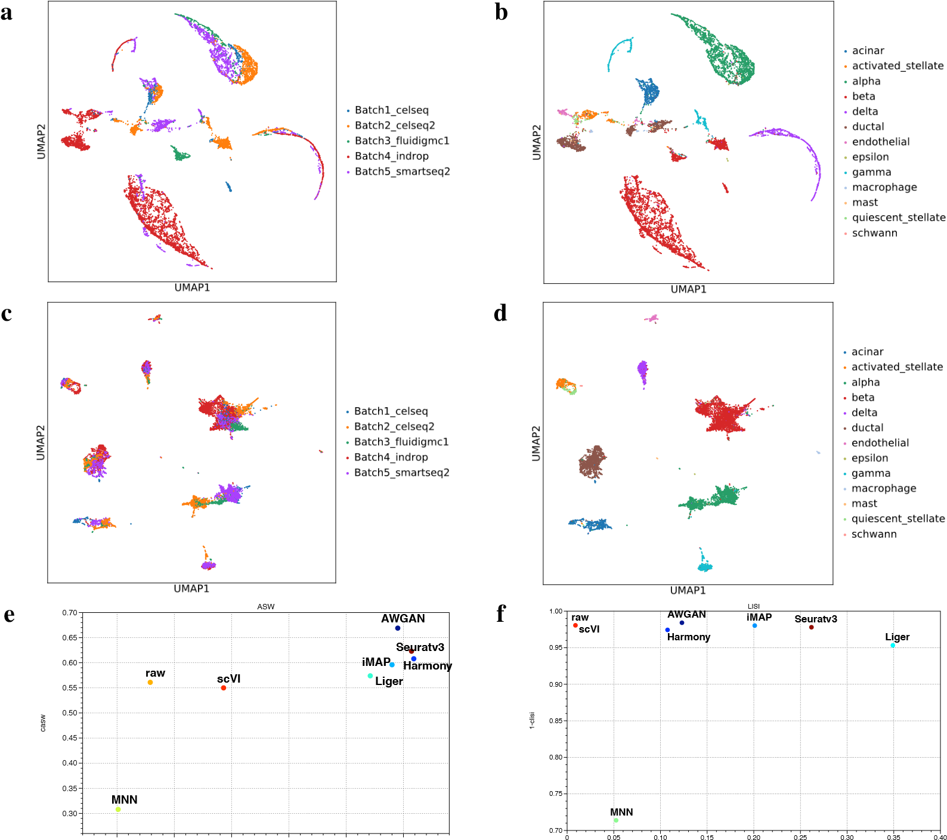

0.30 0.35 0.40 0.45 0.50 0.55

1-basw blisi

Figure 4: Pancreas rm. (a) Visualization for the data distribution with batch label before batch effect removal. (b) Visualization for the data distribution with cell type label before batch effect removal. (c) Visualization for the data distribution with batch label after batch effect removal. (d) Visualization for the data distribution with cell type label after batch effect removal. (e) ASW assessments of different batch effect removal methods on Pancreas rm dataset. (f) LISI assessments of different batch effect removal methods on Pancreas rm dataset.

The Human Pancreas dataset is initially composed of human pancreatic cells from five different sequencing methods. To evaluate the ability of AWGAN on both the mixing of the distribution of common cell types across different batches and discerning the batch-specific cell type, we intentionally removed some cell types from this original dataset. Specifically, we removed acinar and alpha cells from the inDrop batch data, and ductal cells from the CEL-seq batch data. In the end, we renamed the new dataset as Pancreas rm. We can conclude from the visualizations that our model realizes the balance between common cell type mixing and specific cell type discernment across different batches (figure 4). In addition, according to the result in the ASW map and LISI map, AWGAN also performs well based on quantitative results. In the function of common cell mixture, our model performs better than powerful methods like Harmony, Liger and iMAP.

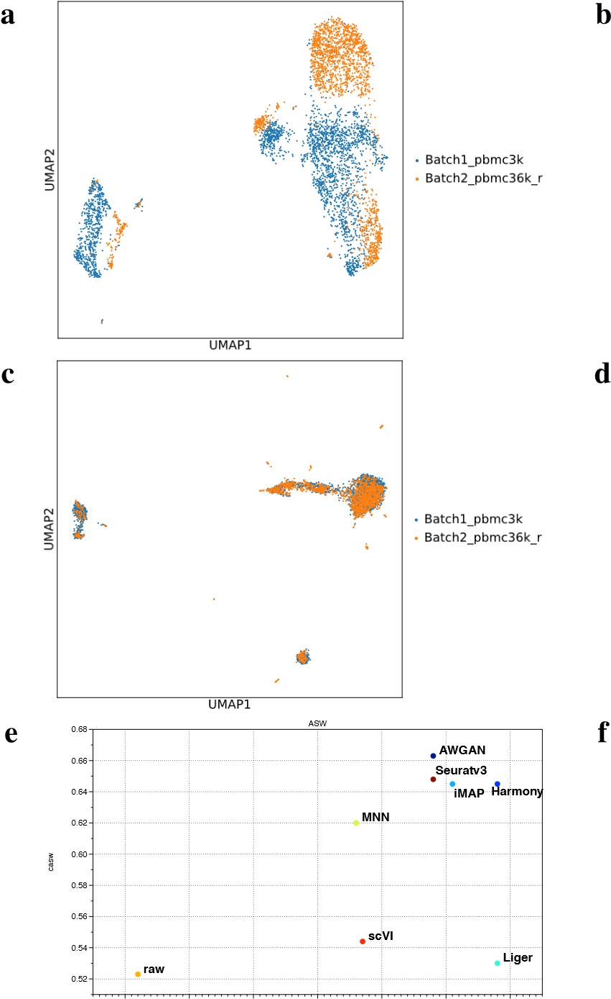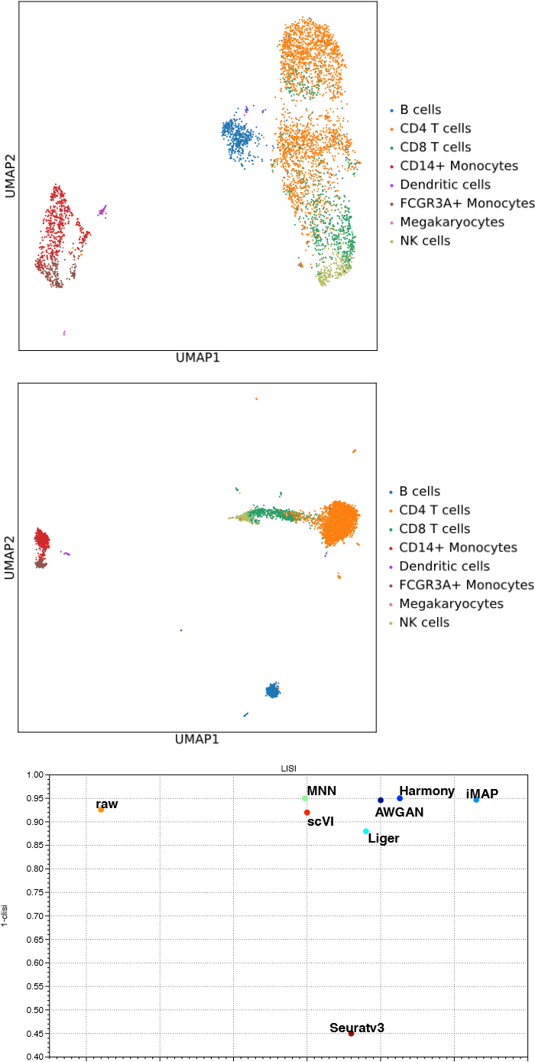

0.44 0.45 0.46 0.47 0.48 0.49 0.50 0.1 0.2 0.3 0.4 0.5 0.6 0.7

1-basw blisi

Figure 5: PBMC 3&68K. (a) Visualization for the data distribution with batch label before the batch effect removal. (b) Visualization for the data distribution with cell type label before the batch effect removal. (c) Visualization for the data distribution with batch label after the batch effect removal. (d) Visualization for the data distribution with cell type label after the batch effect removal. (e) ASW assessments of different batch effect removal methods on PBMC3&68K dataset. (f) LISI assessments of different batch effect removal methods on PBMC3&68K dataset.

The PBMC 3&68K dataset (figure 5) contains two PBMC datasets with different number of cells. For PBMC 3K, we utilized the entire dataset whose number of cells is near 3,000, but for PBMC 68K, we sampled the raw version with 2,000 cells to decrease the workload. The main cell types contained in PBMC are B cells, CD 4/8 T cells, Megakaryocytes and NK cells. According to the steps in the Scanpy document, we first mapped cell type labels from the PBMC 3k dataset to the PBMC 68k reduced dataset by using INGEST [25] and then performed the batch correction work. On this dataset, AWGAN’s performance is still impressive. Because the two datasets do not contain batch specific cell types, so we reached the batch removal target easier. From the visualization part of figure 5, we can conclude that AWGAN can remove the batch effect in this dataset effectively, and most of the benchmark methods cannot exceed our model’s effect based on figure 5 e and f.

It is difficult to determine the true effect of the model from the visualization perspective alone, so we utilized four metrics to quantitatively evaluate the functionality of AWGAN in removing batch effect: ASW rate, kBET rate, LISI rate and Graph Connectivity rate. More details of the metrics can be found in the ’Metrics’ part of Methods. The experimental data for different models are shown in the figure 6.

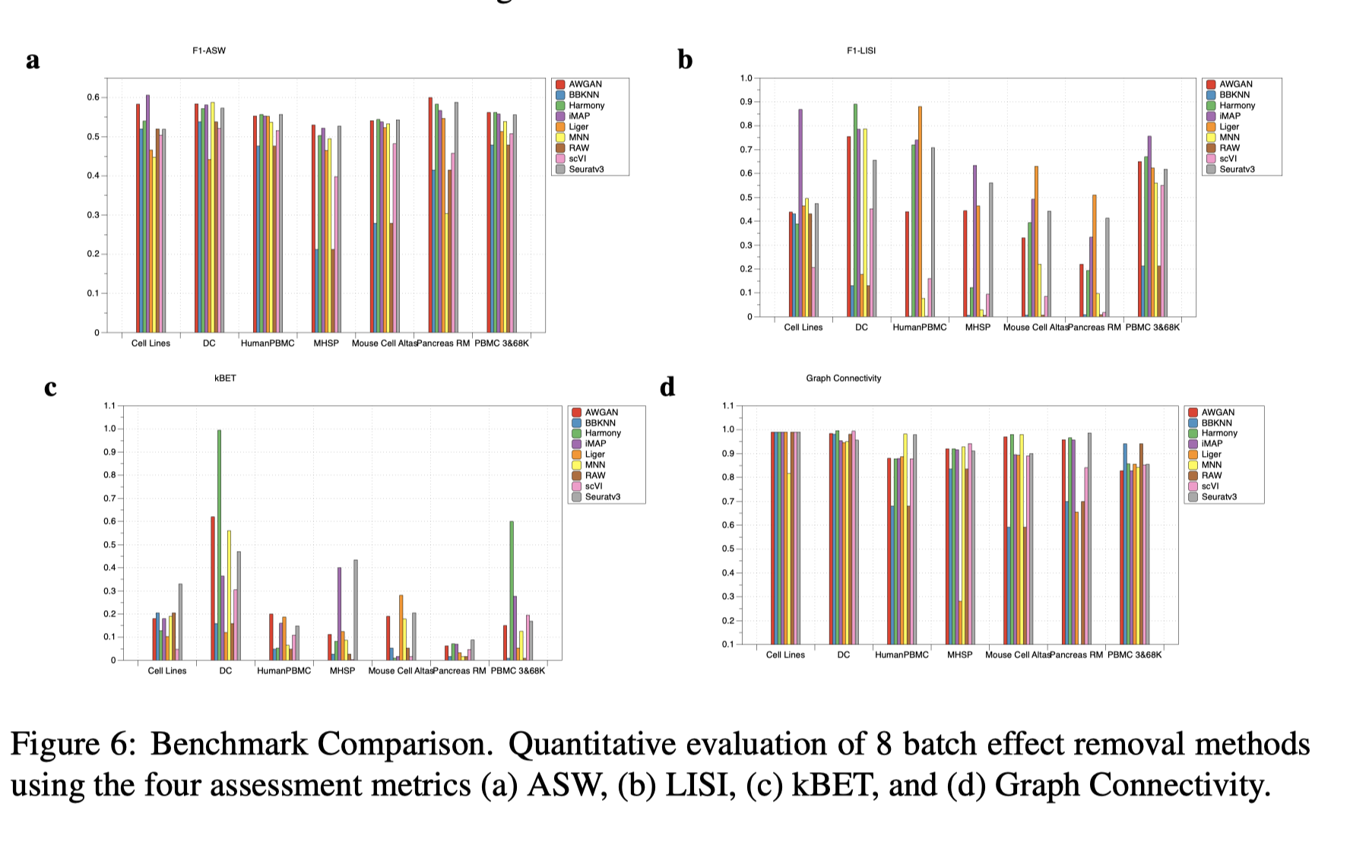

Figure 6: Benchmark Comparison. Quantitative evaluation of 8 batch effect removal methods using the four assessment metrics (a) ASW, (b) LISI, (c) kBET, and (d) Graph Connectivity.

In terms of quantitative comparisons, we find that the effect of different datasets on the quantitative metrics of the model is quite apparent. Moreover, since different quantitative metrics also have limitations, we need to consider the visual and quantitative analysis results to judge the model’s effectiveness. kBET is one example of this flaw. For the reason that sometimes all models perform poorly under kBET evaluation, we believe it is a problem with the dataset. For example, because Pancreas rm contains vastly different cell-type proportions, kBET cannot dertermine whether all neighborhood cells should be significantly mixed [14]. In addition, the value of kBET is also very sensitive to its parameters. Therefore, for the Pancreas rm dataset, it is not very reasonable to use kBET alone to evaluate the results of different models. However, we can change this situation slightly by adjusting the size (percentage) of the kBET sample area and utilizing subsample testing method. In total, we believe that LISI rate, ASW rate and Graph Connectivity rate together with kBET date are sufficient to illustrate the effect of our method.

From the histograms of ASW rate, we prove that AWGAN performs better than nearly all of the other methods in these datasets: Cell Lines, DC, Human PBMC and Pancreas rm. However, for the rest of datasets, confided by the LISI rate and Graph Connectivity rate histograms, the effect of our model may not be reliable enough. The histograms of kBET rate can reflect the effect of mixing cells with common labels in different batch, which confirm this kind of ability of our model. At the same time, our experiment also shows that for some datasets, the simple batch correction method may achieve better results than the relatively more complex method, such as the performance of MNN and Seurat v3 on the DC dataset. After the comprehensive analysis of the quantitative and visual results, we can conclude that iMAP and AWGAN has very close quantitative scores, while other methods’ performance is in large difference.

More kinds of datasets are included in the supplementary file 1 part 2 and part 5. In total, AWGAN performs well in small-scale datasets, especially for datasets with large difference and complex cell type labels.

## Large-scale scRNA-seq Datasets

In this part, we chose four scRNA-seq datasets with more than 30,000 cells and validated the ability of AWAGAN to integrate large-scale datasets. The first dataset is Human Cell Atlas, which is a vast dataset containing more than 700,000 cells. The second dataset is Mouse-Retina dataset, which is constructed by combining Mouse dataset and Retina dataset. The third dataset is Mouse Brain dataset, which contains over 800,000 cells. Due to practical limitation, our device cannot load the whole dataset, so we referred to the selection work finished by [26] and utilized the subsample dataset owning 83,323 cells to eliminate batch effect. The last dataset is a scRNA-seq dataset containing tumor-infiltrating immune cells from colorectal cancer (CRC) [27], and we further investigated the characteristics of this dataset, in particular the possibility of cell misclassification and the score of cell-cell communication. Solving problems related to the large-scale dataset can occupy plenty of space, memory and time. However, our model utilizes a more economical approach to finish the task. We list the analysis results for two datasets in this part, and the results of Mouse Brain dataset can be found in the supplementary file 1 part 3.

a

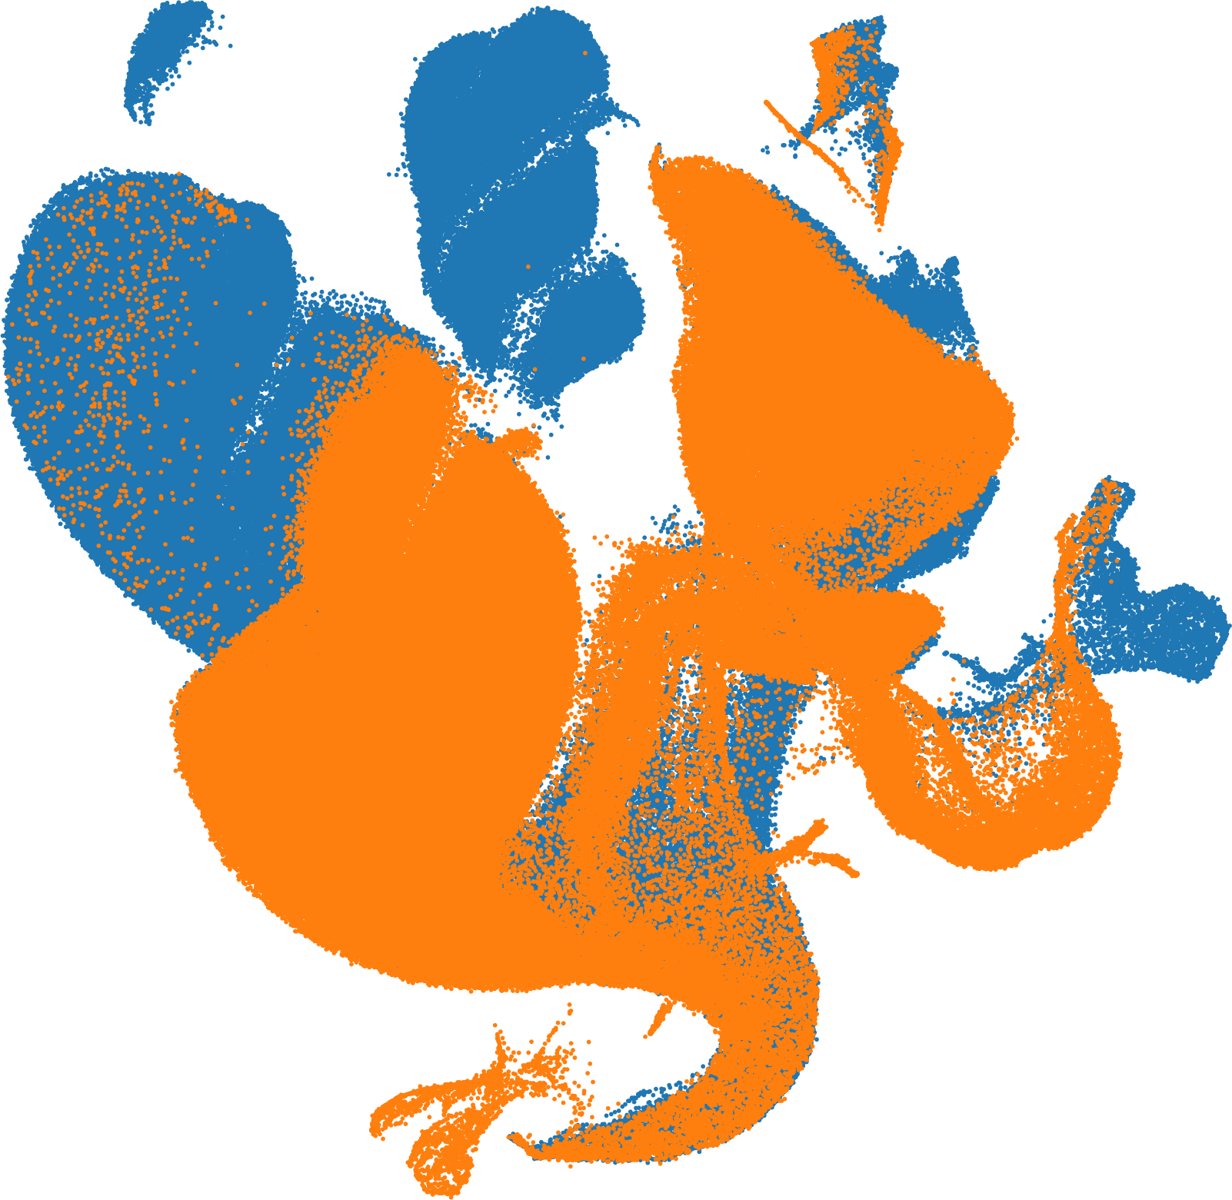

UMAP1

UMAP2

B

a

t

c

h

1

B

a

t

c

h

2

b

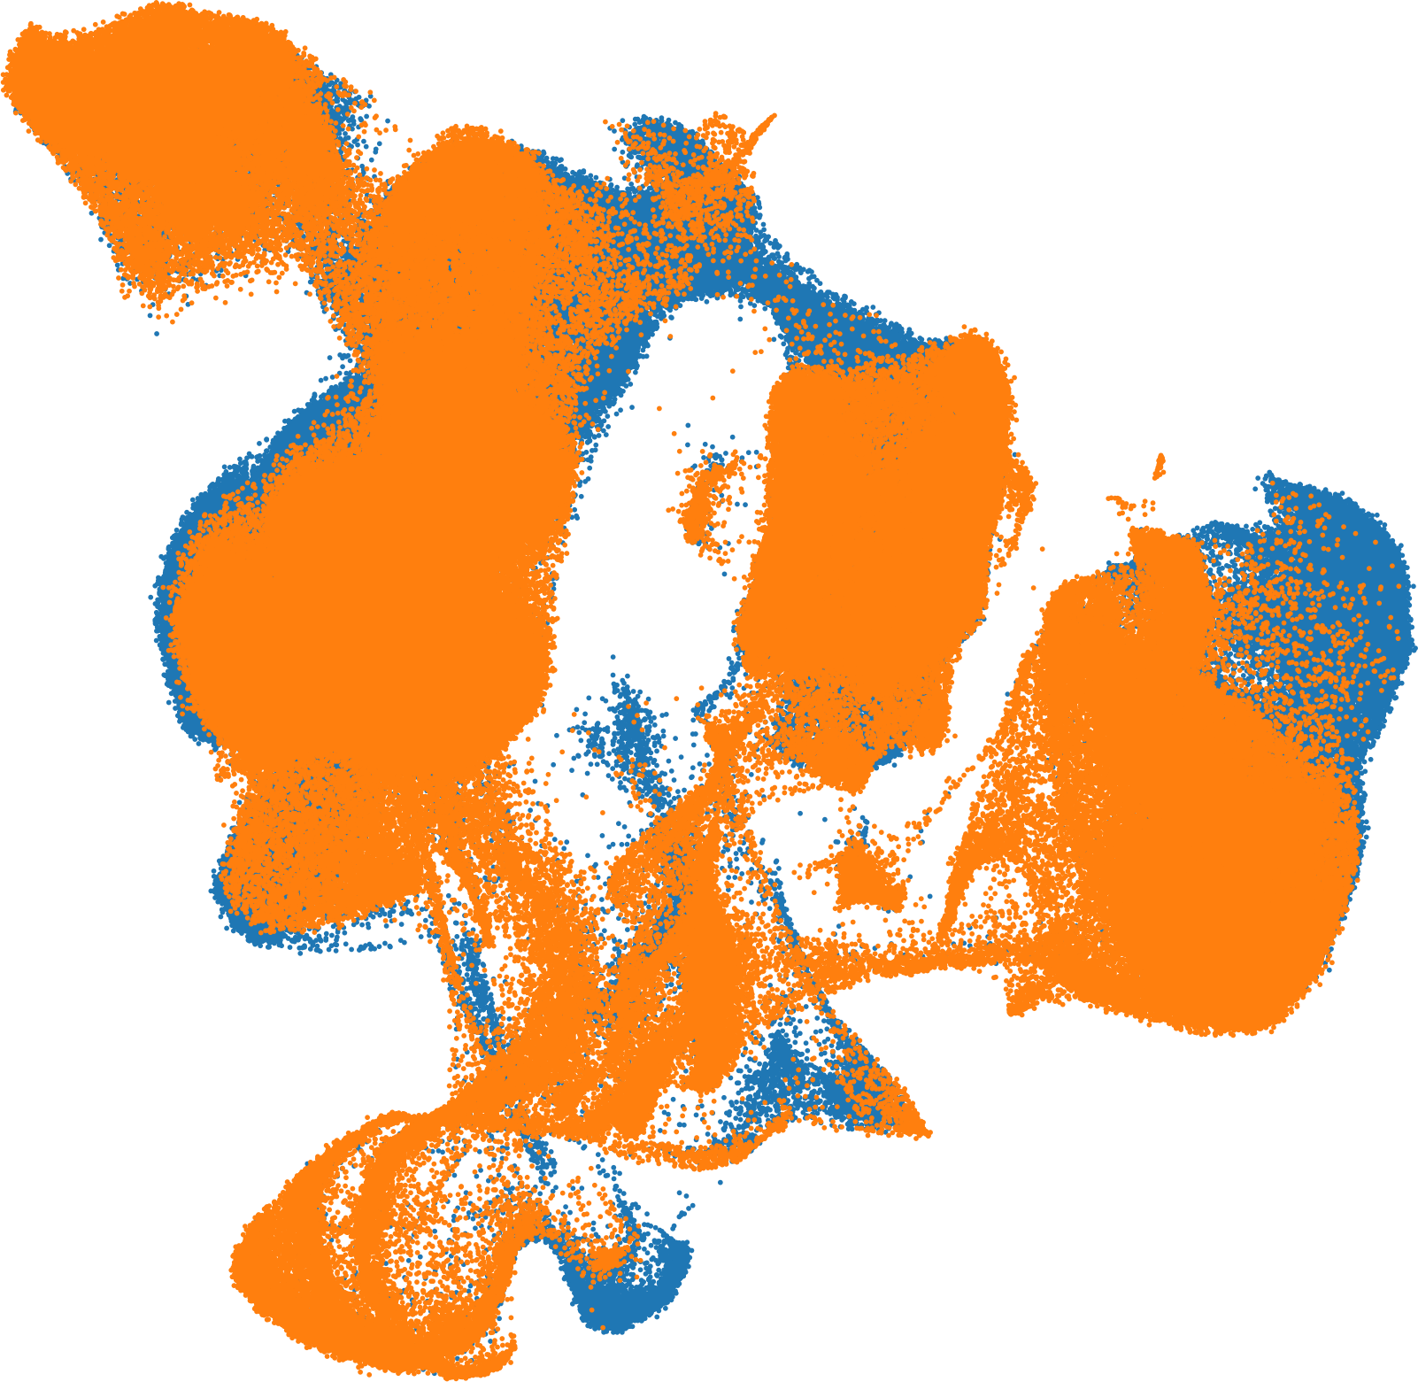

UMAP1

UMAP2

B

a

t

c

h

1

B

a

t

c

h

2

Figure 7: Human Cell Atlas dataset. (a) Visualization for the data distribution with batch label before the batch effect removal. (b) Visualization for the data distribution with batch label after the batch effect removal.

In large-scale datasets, AWGAN also performs well based on figure 7-8. These two selected single-cell datasets have significant batch effect, especially the Human Cell Atlas dataset. Moreover, this

a

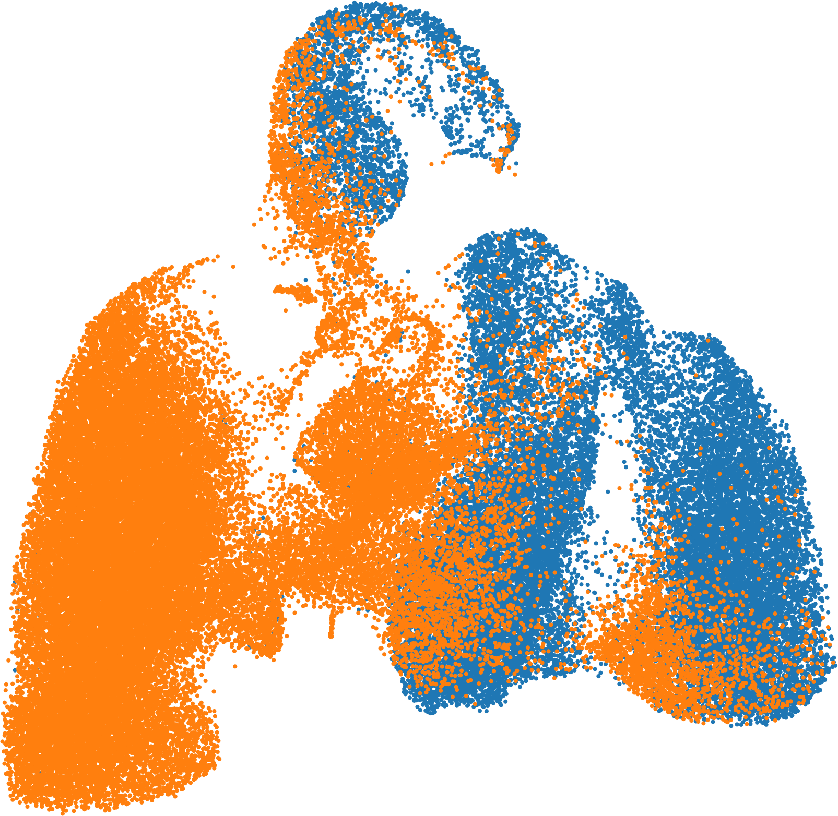

UMAP1

UMAP2

Batch1_Shekhar

Batch2_Macosko

b

c

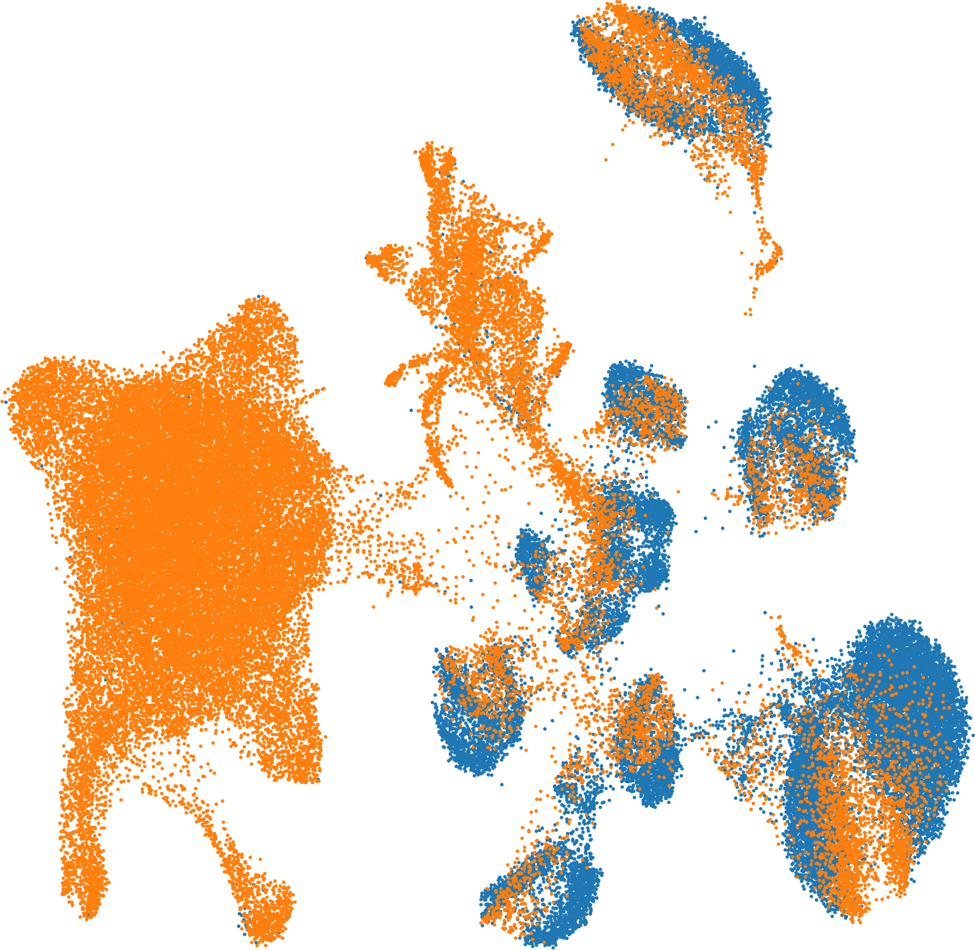

UMAP1

UMAP2

Batch1_Shekhar

Batch2_Macosko

d

e

**Liger**

**iMAP**

**scVI**

**Seuratv3**

**Harmony**

**raw**

**AWGAN**

casw

0.53

0.54

0.55

0.56

0.57

0.58

0.59

0.60

0.61

0.62

0.63

0.64

0.65

0.66

ASW

**MNN**

f

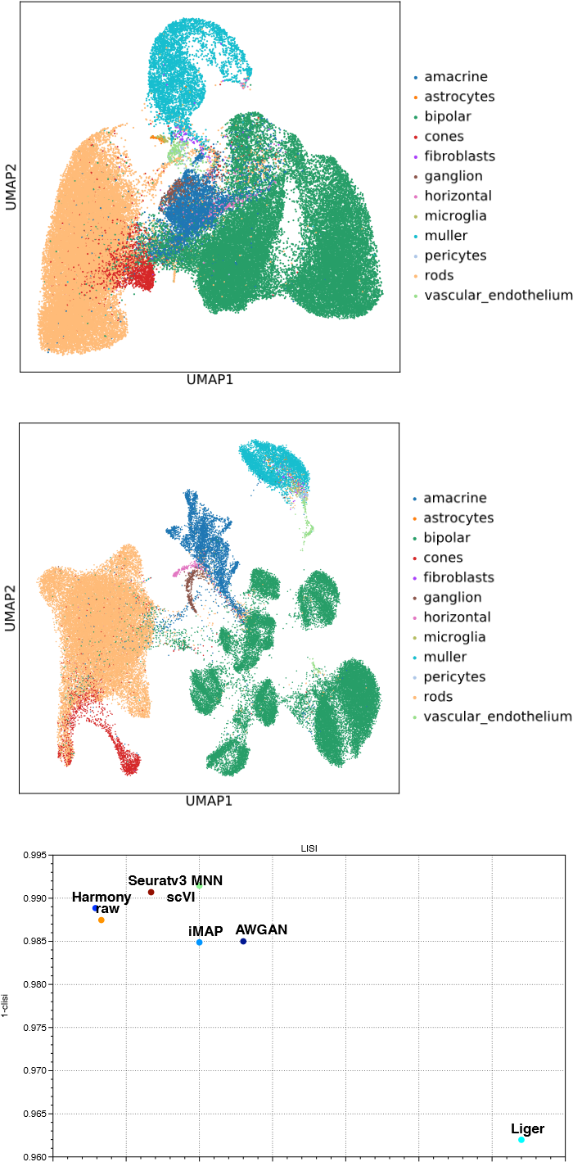

0.34 0.36 0.38 0.40 0.42 0.44 0.46 0.48 0 0.05 0.10 0.15 0.20 0.25 0.30 0.35

1-basw blisi

Figure 8: Mouse-Retina dataset. (a) Visualization for the data distribution with batch label before the batch effect removal. (b) Visualization for the data distribution with cell type label before the batch effect removal. (c) Visualization for the data distribution with batch label after the batch effect removal. (d) Visualization for the data distribution with cell type label after the batch effect removal. (e) ASW assessments of different batch effect removal methods on Mouse Retina dataset. (f) LISI assessments of different batch effect removal methods on Mouse Retina dataset.

dataset has over 700,000 cells, making batch effect removal into a very challenging problem. To save time, we simplify the attention process for this dataset. In total, AWGAN overcomes the obstacles and removes the batch effect in large-scale datasets, which proves that it is a promising model.

Moreover, we took a deeper dive into the functional diversity of AWGAN by looking into the CRC dataset. In figure 9 a-d, we concluded that AWGAN can eliminate the batch effect in the CRC dataset and preserve the biological variation of the dataset. Especially in figure 9 d, we noticed that innate lymphoid cells (ILCs) and CD8 T cells are distributed close to each other in the UMAP after removing batch effects. We assumed that the ILCs are transformed from CD8 T cells. To verify this part, in figure 9 e, based on the heat map clustered by cell type labels, we found the gene expression amount between CD8 T cells and ILCs are very similar. Moreover, from figure 9 f, specific UMAP graph for CD4 T cells, CD8 T cells and ILCs, we also discover that some ILC cells are mixed within the cluster of CD8 T cells. Therefore, we believed that the raw cell type labels of some ILCs may be wrongly marked. This kind of misclassification might be caused by the expression level of the maker gene being too close or the original measurement

error.

We also studied the interactions among different cells. The two batches of CRC dataset were sequenced based on different methods, and the two methods had their own characteristics. The 10X data measure richer cell types and numbers, while the Smart-seq2 data measure more accurate gene expression levels [13,27,28]. Therefore, the former dataset has a significant disadvantage, that is, it can cover up the correlation between some cells, making it difficult for us to accurately calculate the cell-cell communication scores based on the 10X method. AWGAN can solve these problems and discover some new cell-cell interactions. To evaluate the level of cell-cell interactions (communication score), we used CellPhoneDB [29]

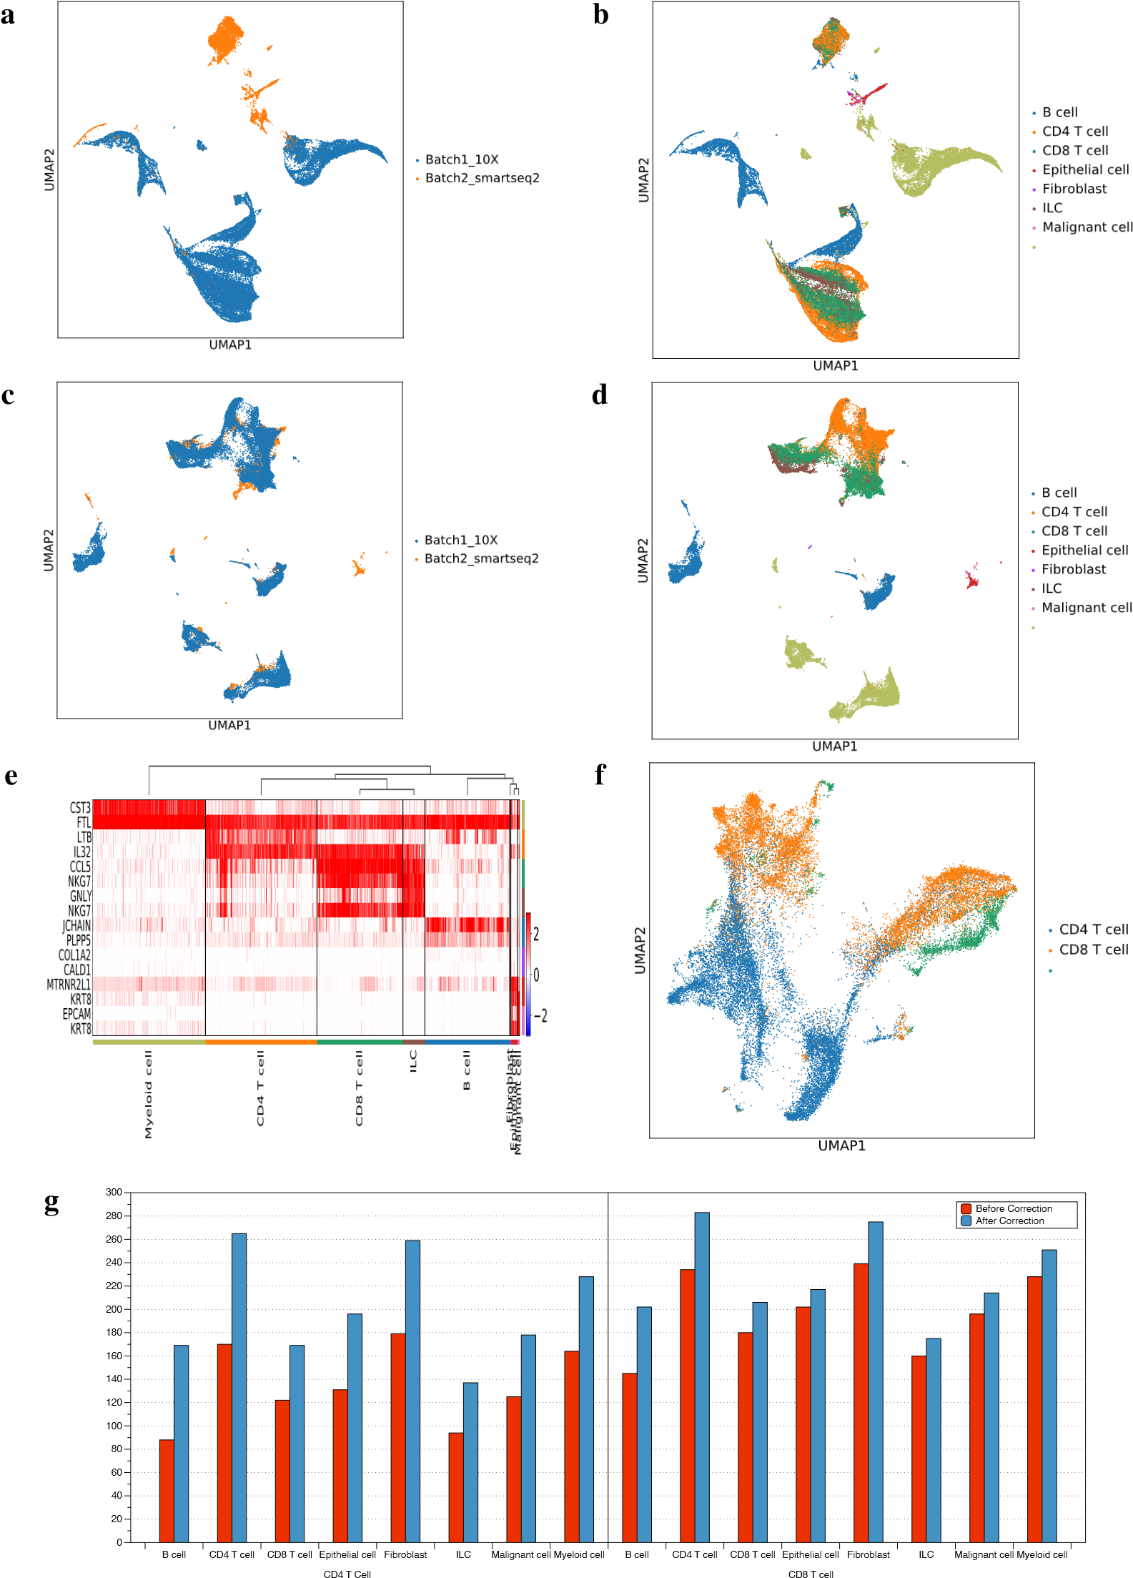Myeloid cell

Myeloid cell

ILC

Figure 9: Research on CRC dataset. (a) Visualization for the data distribution with batch label before batch effect removal. (b) Visualization for the data distribution with cell type label before batch effect removal. (c) Visualization for the data distribution with batch label after batch effect removal. (d) Visualization for the data distribution with cell type label after the batch effect removal. (e) Gene heatmap of CRC dataset after batch effect removal. (f) Visualization for the misclassification data distribution with cell type label after batch effect removal. (g) 18 Significant ligand-receptor pairs (p*<*0.05) defined between all cells and T cells.

to calculate the corresponding value and generate the visualization result. Based on figure 12 in supplementary file 1 part 6, our experiments showed that 10X data after batch correction (10x correct) could find some new ligand-receptor pairs, which could be defined as novel cell-cell interactions. For example, the pair XCL1-CCR5 between CD4 T cells and B cells could only be uncovered by 10x correct data but not by 10x original data. Based on figure 9 g, we found that the number of ligand-receptor pairs of the whole dataset increased after running the AWGAN correction. For more interesting pairs, please refer the supplementary file 1 part 6.

For large-scale datasets, quantitative analysis requires large amounts of memory and consumes plenty of time. This paper compares two types of GAN-based models: iMAP and AWGAN, considering only from the perspective of resource utilization. The results are listed in table 1-3.

|  |  |  |
| --- | --- | --- |
| Model Name | Running Time | Memory Usage |
| iMAP | 280 s | 10 GB |
| AWGAN | 300 s | 4 GB |

Table 1: Mouse-Retina

|  |  |  |
| --- | --- | --- |
| Model Name | Running Time | Memory Usage |
| iMAP | 400s | 10 GB |
| AWGAN | 620s | 4 GB |

Table 2: Mouse-Brain

|  |  |  |
| --- | --- | --- |
| Model Name | Running Time | Memory Usage |
| iMAP | 2040s(HPC) | 30GB |
| AWGAN | 3600s | 20GB |

Table 3: Human Cell Atlas

Notice that for the Human Cell Atlas, iMAP model will collapse in our device since in the step of finding the rwMNN pairs, memory usage will be larger than the valid memory. Therefore, running iMAP in a large-scale dataset without the help of High Performance Computing (HPC) is very difficult to achieve because it has a high requirement for device function. However, using AWGAN, our device can still generate the result. AWGAN only runs the attention step once to use memory more wisely in the computer, compared with iMAP method.

## Running Time Comparison

We list the relation between running time and dataset size for different batch correction methods in figure 10.

Human PBMC

Pancreas rm

Cell Lines

Mouse Cell Atlas

MHSP

PBMC 3&68K

DC

AWGAN

BBKNN

Harmony

iMAP

Liger

MNN

scVI

Seuratv3

Type of Methods

253.0

28.0

166.07

157.43

311.4

1735.1

107.0

81.0

460.0

29.14

380.0

316.0

1560.0

473.0

461.56

253.0

232.0

23.01

130.0

464.64

200.22

259.5

346.0

100.0

137.0

18.15

190.0

123.0

1500.0

204.0

46.66

30.0

76.68

1.0

30.86

96.64

480.0

147.59

81.0

25.0

97.77

5.34

26.0

86.0

60.0

91.0

70.0

30.0

9.68

2.49

4.0

64.0

169.2

4.0

21.07

10.0

0.2

0.4

0.6

0.8

1.0

1.2

1.4

1.6



Type of datasets

Figure 10: The comparison results of running time over dataset size. Datasets are ordered based on the size of the specific dataset. The datasets closer to the left are larger in size. The running time is normalized (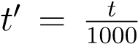) for better visualization and the real running time (in seconds) for each scenario is annotated on the graph. The warmer the icon is, the longer it has been running. Similarly, the larger the area of the icon is, the larger size that the dataset has.

MNN and Liger are the two most time-consuming methods across all the datasets, while BBKNN and Seurat v3 are the fastest two methods for running on most datasets. This might because BBKNN and Seurat v3 do not involve large matrix decomposition as Liger does or complex maching learning process as other methods. As for AWGAN, its running time is relatively short in most datasets among all the machine-learning based methods (e.g. iMAP, harmorny and scVI). In general, AWGAN can basically complete all batch correction tasks in a short period of time, thus saving resources for researchers.

# Discussion

In total, as a novel model for removing batch effect, AWGAN shows its efficiency by dealing with problems among different kinds of datasets. With a framework based on deep learning theory and generative models, AWGAN utilizes attention strategy to generate nearest neighbor pairs as a training set and yields ideal results in a relatively shorter time compared with other methods.

More specifically, except for Harmony and iMAP, AWGAN achieves better results than the traditional batch effect removal algorithm in both ASW score and LISI score in most of the datasets. Compared with the latest model iMAP, both of them have advantages on different datasets. However, iMAP has a pronounced vulnerability: the model often crashes (see figure 13 in supplementary file 1 part 9), because iMAP chose a fixed *λ*, while ignoring the impact of different data distribution on the model training. *λ* is used to make sure that the gradient satisfies the 1-Lipschitz [20] condition. Otherwise, the training steps of WGAN cannot be convergent. AWGAN excludes this problem by using the adaptive *λ* approach.

Some quantitative results of the Harmony method are high. However, this method has a very obvious drawback: Harmony does not consider the conservation of cell type labels, i.e., it ignores biological variation and overemphasizes data integration function. For biological research, this drawback is very critical. We can see this from the figure 14 in supplementary file 1 part 9 that CD1C cells are mapped to another kind of cells, and such a result is unacceptable to us. So overall Harmony model is not performing as well as AWGAN.

Moreover, for batch correction methods like Harmony, scVI and BBKNN, there are some flaws in the method design principles. For Harmony, the visualization of most of batch correction data is acceptable, but when it tries to find the neighbors in different clusters, it does not consider batch specific cells. For scVI, this method extracts the gene expression statistics as an embedding in another space, so we need to regenerate the count matrix through a decoding model. Therefore, this variational inference method is even more complex based on its work. For BBKNN, this method is similar to the neighbors function in Scanpy [25], which can only make the visualization result better. BBKNN does not manipulate the raw data, so it cannot contribute much in downstream analysis. Nevertheless, methods like AWGAN, Liger, MNN, Seurat v3 and iMAP can adjust the original gene expression data and provide a better basis for downstream analysis.

In order to summarize our experimental results and demonstrate the advantages of AWGAN more comprehensively, we define the following function:



*TotalRank*(*d,m*) means getting the total rank sum of method *m* by adding all the rank values of this method under different metrics conditions for dataset *d*. The set *M* contains all the metrics we utilized in our experiment. Moreover, the function *Rank*(*d,i,m*) means getting the rank of the given method *m* by the sorted result list of dataset *d* generated by matrix *i*. From the definition, we can conclude that the smaller the TotalRank value is, the better the method shall be. The table 4 presents the result of *TotalRank* function.

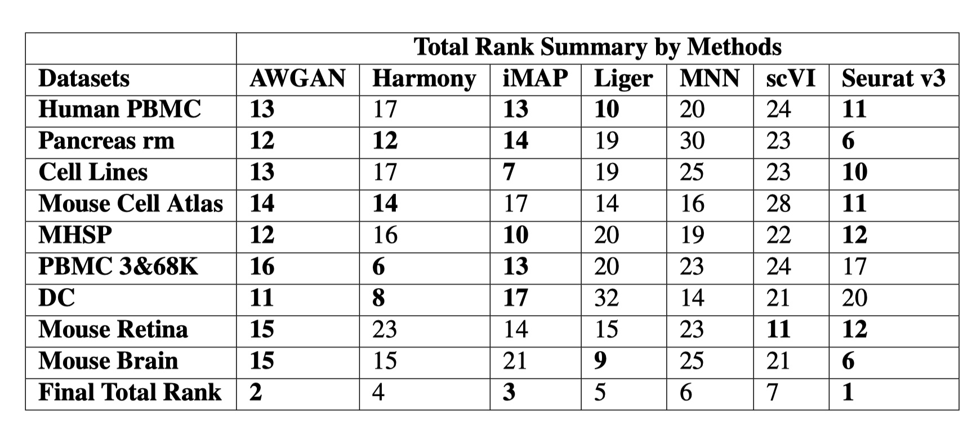

The bolded sections indicate that the methods corresponding to the column are the best 3 performed overall under the row corresponding dataset. From our final result, AWGAN performs better than other methods except Seurat v3 in most of the datasets. This result proves that AWGAN has a strong generalization ability.

In the problems related to large scale data, AWGAN can also overcome the memory limitation problems and finish the batch correction task without collapse error. In addition, in the research related to CRC dataset, AWGAN shows its ability to find out misclassification cells and uncover the hidden cell-cell interactions. Overall, in most of the cases, the performance of our model on the datasets mentioned in this paper is better than current approaches.

# Conclusion

We demonstrated that AWGAN is a very advanced model through both theory and experiments. It takes the advantages of deep learning models and also uses relatively few resources to achieve better results. Firstly, AWGAN can remove the batch effect in different datasets and preserve the biological variation (for example, gene expression difference and cell type distribution), while other state-of-the-art models, for example, iMAP, Harmony and scVI, fail to keep it in some conditions. Secondly, our model supports various improvement extension applications, and researchers can adopt many hyper-parameters in our model, like training epochs, batch size, *λ* or even the weight of attention. The strong adaptability of our model also allows it to be continuously improved to achieve better results. Thirdly, running our model does not require very high technique or advanced device. Researchers can choose to use either cloud platform or CPU core in a personal computer to train our model and get a satisfactory result. We believe that the output of our model can play a more critical role in downstream biology analysis areas, such as disease prevention and diagnosis, specific cell function analysis, cell heterogeneity analysis and other work.

# Methods

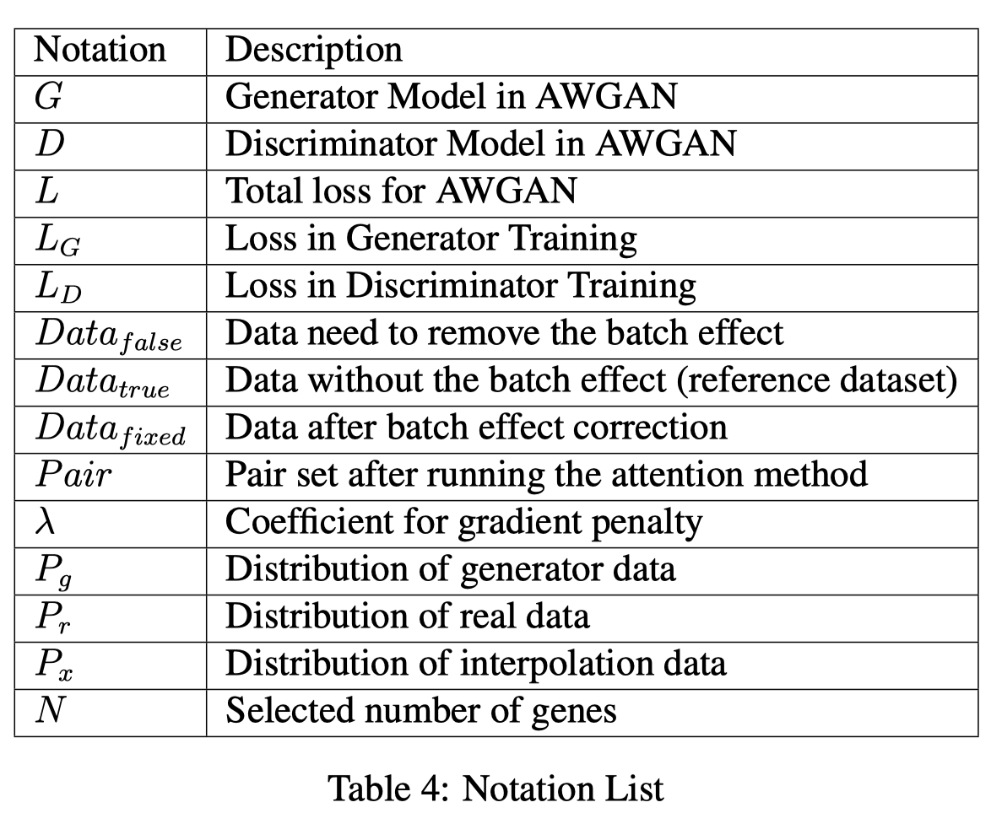

## Attention-driven Data Pre-processing

We observed that most studies on batch effect removal chose a valid gene number within the range of at least 200 and up to 2000 (*N* ∈ (200*,*2000)) [13, 26] based on highly variable gene (HVG) filtering method designed in Seurat v3 [11]. In this paper, we followed the above rules and process the raw count matrix. After obtaining the filtered count matrix, we proceed to the step of generating the training set. In this paper, inspired by the basic attention mechanism, we constructed nearest neighbour cell pairs using cosine distance. For the set of cells with larger cosine similarity, we considered them as the nearest cell pair, and their attention to each other was 1, while the attention of the rest of the cells to them was 0. This type of relationship of attention was not transmissive but satisfies the principle of superposition. Therefore, any cell in the query dataset could find its own nearest neighbour cell in the reference dataset, generating a neighbour cell pair. The definition of nearest neighbour cell pairs can be explained as the figure 11. To find the NNP, we only need to solve the following optimization problem. Assume

**Batch 2**

**Batch 1**

**T cell**

**RBcell**

**B cell**

**Pairs**

Figure 11: A schematic diagram of Nearest Neighbour Pairs (NNP) under the visualization PBMC dataset after dimension reduction. The pair relation is constructed when the dimension of cell data has not been reduced.

there are two scRNA-seq datasets *Datatrue* (usually reference dataset) and *Datafalse* (usually combined with all the extra batch data, which is defined as query dataset), our target is to find:

 (2)

*Ci* ∈ *Datatrue,Cj* ∈ *Datafalse* (3)

We utilized an iterative algorithm with Numba acceleration [30] to solve this problem and collect the ideal solution. Here we declared that our algorithm always prefers to find cell pars with the largest cosine similarity (based on cosine value of two vectors). Based on this rule, sometimes NNP may not choose cells with the same cell type label, but since this situation is very rare and to save time for running the attention matching algorithm, we reserved this mechanism (other methods like MNN [10], iMAP [13] also ignore the effect of cell types). NNP with different cell type labels has little effect on the normal operation of the model, and we verified this in part 5.2. The algorithm for finding the target pairs is shown in Algorithm 1.

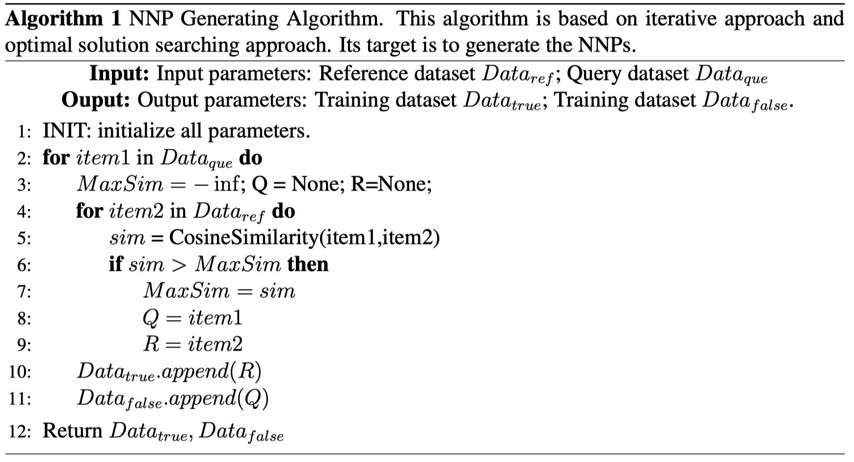 We also considered some examples of variations in this algorithm, including selecting more pairs and considering the construction of training sets after averaging multiple attention pairs.

However, the above selection effects are not as good as the decision in Algorithm 1. Details of the experiment can be found in the supplementary 1 file part 4.

## AWGAN Training

|  |  |  |  |
| --- | --- | --- | --- |
| Generato | r | Discriminator | |
| Layer Type | # | Layer Type | # |
| Input Layer | *N* | Input Layer | *N* |
| Hidden Layer | 1024 | Hidden Layer | 1024 |
| Batch Norm | 1024 | Hidden Layer | 512 |
| Hidden Layer | 512 | Output Layer | 1 |
| Batch Norm | 512 | - | - |
| Hidden Layer | 1024 | - | - |
| Batch Norm | 1024 | - | - |
| Output Layer | *N* | - | - |

Table 5: AWGAN Structure

Description of notations used in this section can be found in table 5 and the structure of AWGAN is shown in the table 6. For the generator model, we applied the batch normalization [31] technique to accelerate the training speed, and we also utilized the Dropout method [32] based on momentum to prevent the model from overfitting. Based on the requirement in WGANGP [20], we removed the BatchNorm layer for the discriminator model because we intended to ensure the smooth requirement for Lipschitz condition could not be affected by batch normalization layers. The minimization optimization target of our model can be concluded as :

 The first two terms mean the Wasserstein Distance, which is the original expression in WGAN that we intend to minimize. However, if we minimized this value directly, the K-Lipschitz condition could not satisfy well. To satisfy the K-Lipschitz condition, the original WGAN used a direct parameter range limitation. However, as the training progresses, the parameters will spontaneously concentrate on the boundary, so the gradient will not be well passed back to the model. Therefore, we introduced the third term and the gradient penalty mechanism [20]. The third term, gradient penalty, will first interpolate the sampling between true data and fake data and obtain a new distribution. In this problem, proved by the WGAN-GP paper, we took *K* = 1 because the L2 norm of the ideal gradient for WGAN is 1 (1-Lipschitz condition) [20]. We then used this new distribution to compute the gradient penalty to match the Lipschitz condition over as large as possible space, thus eliminating the negative effects of parameters on the boundary. Some researchers agree with the idea to set *K* = 0, which is more reasonable [33]. We provided our experiment results with this choice in the supplementary file 1 part 1 and proved that there is no significant difference between these two choices. The interpolation function between the *True* dataset and *Fake* dataset (including raw Fake data and temporary *G*(*Fake*) data) is defined as:

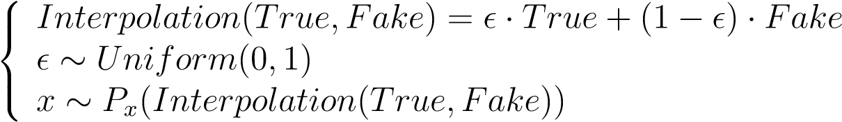 (5)

For the choice of the activation function, we utilized the state-of-the-art activation function: Mish [34] to construct our model. The expression of Mish function can be defined as :

*Mish*(*x*) = *x* · *tanh*(*ln*(1 + *ex*)) (6)

where *f*(*x*) = *ln*(1 + *ex*) is also known as SoftPlus function. Mish function has smoother gradient compared with Rectified Linear Unit (ReLU) [35] function, and smoother activation function allows better information integration and information mining performed by the deep neural network [34].

For the output layer of the generator, we adopted ReLU function with ResNet structure

[36], which is also known as identity shortcut connection, to generate more stable results. To implement the ResNet structure, we changed the expression of output layer into this form:

*Y* = *T*(*F*(*X,*{*Wi*}) + *WsX*) *T,F* ∈ *set*(*Activation Functions*) (7)

{*Wi*} means the set of inner weight matrix. *Ws* is a linear map which helps to ensure the feature dimensions of X and F(X) are consistent. In this problem, their feature dimensions are the same, so *Ws* can be treated as identity mapping. To make our model perform better in different dataset situations, we defined a new function for output layer, the transformation function *T*. For datasets which originally utilize log preprocessing method, we set *T* = 1, otherwise, *T* = *ReLU*().

From the perspective of the back-propagation algorithm, we always met non-zero terms when you are trying to find gradients based on ResNet structure, so the problem of gradient vanishing and white noise (very small gradient) can be solved to some extent [37].

For the overall formal design of the generator, inspired by the encoder-decoder model, we also added features such as embedding generation and embedding decoding in our network, which can extract the biological variation in scRNA-seq data.

In most of the time, since cells are highly differentiated, there are significant differences in gene expression between different types of cells, so theoretically, it is easy for us to distinguish batch specific cells [38,39]. However, sometimes there may exist cells with similar gene expression levels but different cell identification. For this kind of problem, we utilized the Discriminator and Dropout method design to us help keep the balance between mixing the cells in different batches and discerning batch specific cell types. Firstly, the discriminator is designed to identify the cells in different batches. For batch specific cells, the discriminator is able to quickly treat them as cells in other batches, and the model will not evaluate this situation. Secondly, mixing the batch specific cells into known cells can be treated as an overfitting problem. Dropout method is designed to solve this kind of problem. Moreover, adjusting the training epochs and batch sizes can also generate a better result, depending on the chosen dataset. The figure 12 is utilized to illustrate the function of discriminator:

**a** Training Dataset Discriminator



Train Continue

Cell type 1

Batch 1

Cell type 1

Batch 2

Small Divergence Difficult to discriminate

Training Dataset Discriminator



Train Stop

Cell type 1

Batch 1

Cell type 2

Batch 2

Large Divergence Easy to d49iscriminate

Figure 12: The principle of discriminator to help us discern batch specific cell types.

In total, the training algorithm can be found in Algorithm 2.

## Model Adjustment and Evaluation

There are five kinds of parameters that can be adjusted in our model: epoch, batch size, gradient penalty, dropout rate and learning rate. Moreover, for the choice in calculating the gradient penalty, we preferred using raw *Fake* data for the first attempt. If the results were not satisfied, we would shift to temporary *G*(*Fake*) data. The strategy we chose to improve the performance of our model was based on both the visualization result and quantitative assessments (especially ASW rate and LISI rate). We also referred from the stage2 of iMAP’s structure for network design [13]. Finally, we chose the combination of different parameters which could optimize the quantitative rates and visualization performance. The choice for all key hyperparameters can be found in supplementary file 1 part 7. Moreover, for all the datasets, we run our model 10 times in each dataset to ensure that our output is convergent and stable.

To evaluate AWGAN and other methods except for

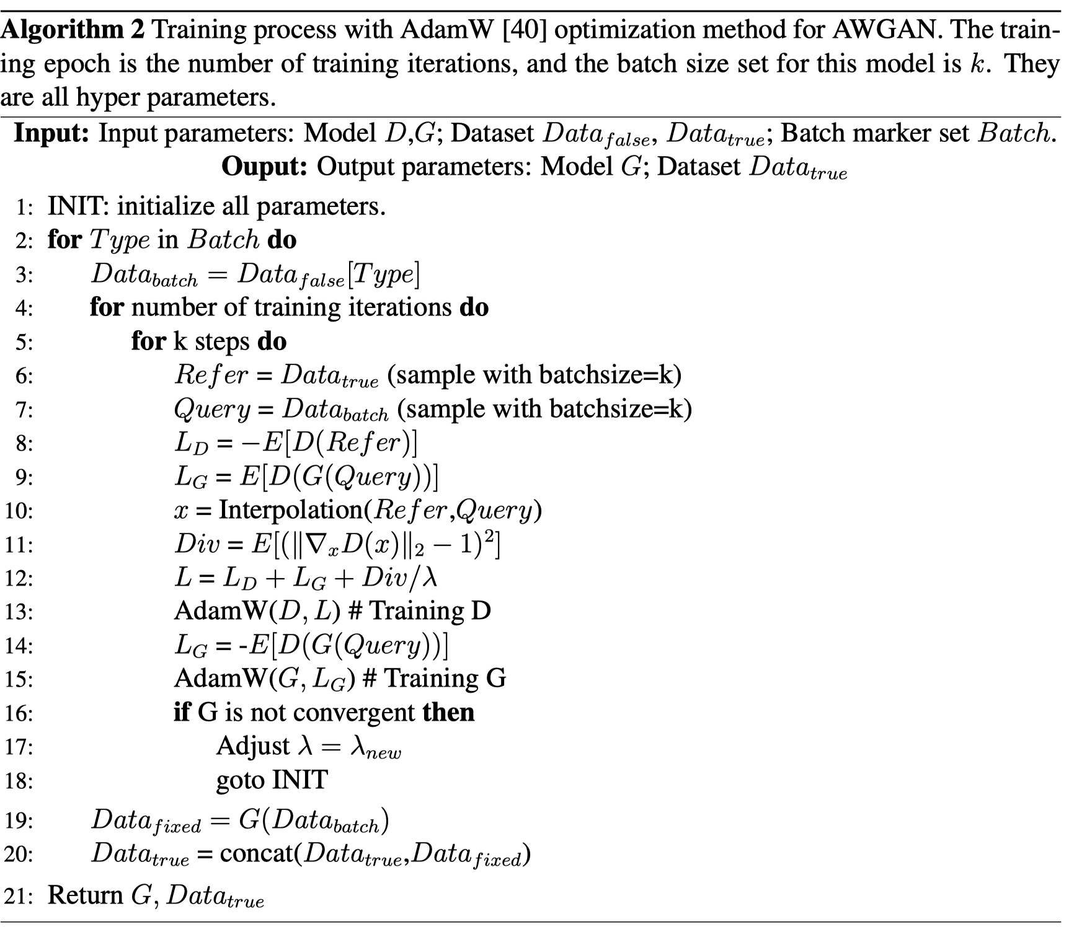 Liger and BBKNN, we used the top 20 PCs [26] based on PCA method [41] with batch information and cell type information of the processed data as the input part for all the four quantitative metrics. For Liger, we chose to evaluate the norm matrix of the data generated by Liger with the original batch and cell type information. For BBKNN, since this method does not generate either gene expression information or latent space information, we did not compute metrics on this method. The visualization of quantitative comparison can be found in the ’Results’ part and the details of quantitative results can be found in the supplementary file 3.

## Metrics Details

* ASW: Average silhouette width, as known as ASW, is computed based on cluster and average distance. For one data point, we first used the average distance between this point and other points in a neighboring cluster to minus the average distance between this point and other members in the same cluster. After finishing this step, we divided this result by the larger distance to get the silhouette value. We repeated the process for each data point for a certain number of iteration times and took the average across them. Therefore, the formula to calculate ASW can be defined as:

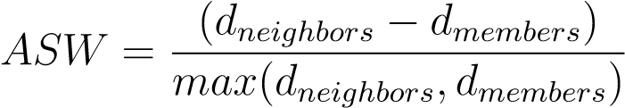 (8)

Since we normally had two kinds of clusters: batch and cell type, we used F1 score of ASW to evaluate our model. The F1 score of ASW can be defined as:

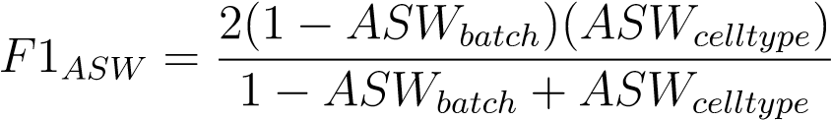 (9)

For the F1 score, since we intended to make sure that the batch can be integrated in one reference dataset, and we also intended to keep the cell type distribution is same, so the model with low *ASWbatch* rate and high *ASWcelltype* rate will be confirmed as good model. Therefore, if the F1 score of one model is higher, this model is also better than

others.

* kBET: k-Nearest neighbor batch-effect test, as known as kBET, utilizes kNN-based algorithm to measure the results of batch effect removal. The algorithm randomly selects some data points and test whether the local batch label distribution among them is similar to the global distribution. Ideally, the batch label distribution in the sample and the global data distribution should be very close to each other, so the rejection rate should be 0. In fact, there are some differences between the two, so we get an actual rejection rate between 0 and 1. To be consistent with the rest of the methods, we defined acceptance

rate as:

*AcceptanceRate* = 1 − *RejectionRate* (10)

If the acceptance rate of one model in one dataset is higher, this model also performs better in this dataset than others.

* LISI: Local inverse Simpson’s index (LISI) adopts similar principle to kBET, but the rule for choosing the neighbors in kNN is different from kBET. LISI chooses neighbors based on the local distribution of distances with an invariant perplexity. Moreover, the chosen neighbors will be used to calculate inverse Simpson’s index, which is the number of accepting cells in neighbors. The definition of Inverse Simpson’s rate is:

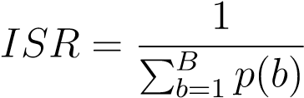 (11)

Where b in the index of cells and B is the cluster of one batch. ISR is the batch probabilities in local neighbors. Since LISI assigns a value for every different cells, we evaluated our model based on average LISI rate. if it approaches to the real batch number, the model with such LISI is better than others. According to the definition of LISI rate, we defined two metrics: cell type LISI rate (cLISI) and batch LISI rate (bLISI). We intended to enlarge the bLISI rate while decrease the cLISI rate. Therefore, we utilized F1 score of LISI to evaluate our model. The F1 score of LISI can be defined as:

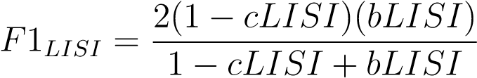 (12)

* Graph Connectivity: This method is based on kNN and its target is to evaluate the conservation of cell type distribution after batch correction work [5]. For the kNN graph *G*, of one set of integrated data, we evaluated whether cells with cell type label *c* are directly connected with each other across batches. Moreover, we could create the subset kNN graph *G*(*Nc,Ec*) only for the cluster with cell type label *c*. Let *T* represent the set containing all cell type labels, we could use this equation to compute the graph connectivity score:

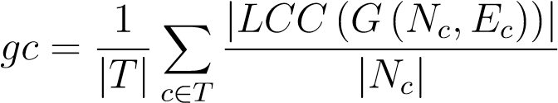 (13)

In this equation, |*LCC*()| means the number of nodes in the largest connected component

(LCC) of the given graph, and |*Nc*| means the number of nodes with cell type label *c*.

Based on the concept of LCC, higher graph connectivity score means better method.

## Device Information

The CPU of our device is Intel(R) Xeon(R), 2.30 GHz. The GPU of our device is NVIDA Tesla P100, the RAM is 25GB, and the hard disk size is 140GB. The version of Pytorch is 1.7.0 [42]. To run Liger and Seurat v3 in R, we also utilized a device with CPU: Intel(R) Core(TM) i5, 2.50GHz, RAM:12GB. To run iMAP on human cell atlas dataset, we use a HPC tool. To make life easier, the Colab platform under Google can meet the most needs of running our code.

## Dataset

We utilized eleven single-cell datasets to prove the efficiency of AWGAN in details, including seven small-scale datasets and four large-scale datasets. Cell Lines dataset [43] is generated by 10x Genomics with three different batches. DC dataset [44] is composed of two different batches based on the Smart-seq2 protocol. Pancreas rm dataset [13] includes human pancreatic cells measured by 5 different platforms and is loaded from R package: SeuratData. PBMC 3&68K [28] is also generated by 10x Genomics, and it is worthy to mention that PBMC 68K is the dataset with processed version. MHSP dataset [45] [46]is acquired by researchers using the Mars-seq protocol and the Smart-seq2 protocol. Mouse Cell Atlas dataset [47] [48] contains two batches from the Microwell-seq and the Smart-seq2 protocol. Human PBMC dataset [43] is generated by 10x Genomics protocol with two batches. Human Cell Atlas dataset is a large dataset with bone marrow cells in batch 1 and cord blood-derived cells in batch 2 based on the 10x Genomics protocol. Mouse Retina dataset [50] [51] is composed of mouse retina data generated using the Drop-seq technology by two unassociated laboratories. Mouse Brain dataset [52] [53] is composed of two datasets from two different research groups, which were generated by Drop-seq and SPLiT-seq protocols separately. CRC dataset [27] is a scRNA-seq dataset provided by 18 CRC patients using both Smart-seq2 and 10x Genomics.

## Code Availability

An open-source implementation of the AWGAN and codes to reproduce the results can be downloaded from: https://github.com/ChineseBest/AWGAN.

## Data Availability

Download approaches for the datasets we used in this paper can be found in the supplementary file 2.

# References

1. E. Papalexi and R. Satija, “Single-cell rna sequencing to explore immune cell heterogeneity,” *Nature Reviews Immunology*, vol. 18, no. 1, p. 35, 2018.
2. B. Pijuan-Sala, C. Guibentif, and B. Gottgens, “Single-cell transcriptional profiling: a¨ window into embryonic cell-type specification,” *Nature Reviews Molecular Cell Biology*, vol. 19, no. 6, pp. 399–412, 2018.
3. M. L. Suva and I. Tirosh, “Single-cell rna sequencing in cancer: lessons learned and` emerging challenges,” *Molecular cell*, vol. 75, no. 1, pp. 7–12, 2019.
4. J. T. Leek, R. B. Scharpf, H. C. Bravo, D. Simcha, B. Langmead, W. E. Johnson, D. Geman, K. Baggerly, and R. A. Irizarry, “Tackling the widespread and critical impact of batch effects in high-throughput data,” *Nature Reviews Genetics*, vol. 11, no. 10, pp. 733–739, 2010.
5. M. Luecken, M. Buttner, K. Chaichoompu, A. Danese, M. Interlandi, M. Mueller,¨ D. Strobl, L. Zappia, M. Dugas, M. Colome-Tatch´ e, and F. Theis, “Benchmarking´ atlas-level data integration in single-cell genomics,” *bioRxiv*, 2020. [Online]. Available: https://www.biorxiv.org/content/early/2020/05/23/2020.05.22.111161
6. M. E. Ritchie, B. Phipson, D. Wu, Y. Hu, C. W. Law, W. Shi, and G. K. Smyth, “limma powers differential expression analyses for rna-sequencing and microarray studies,” *Nucleic acids research*, vol. 43, no. 7, pp. e47–e47, 2015.
7. W. E. Johnson, C. Li, and A. Rabinovic, “Adjusting batch effects in microarray expression data using empirical bayes methods,” *Biostatistics*, vol. 8, no. 1, pp. 118–127, 2007.
8. J. D. Welch, V. Kozareva, A. Ferreira, C. Vanderburg, C. Martin, and E. Z. Macosko,

“Single-cell multi-omic integration compares and contrasts features of brain cell identity,” *Cell*, vol. 177, no. 7, pp. 1873–1887, 2019.

1. R. Lopez, J. Regier, M. Cole, M. Jordan, and N. Yosef, “Bayesian inference for a generative model of transcriptome profiles from single-cell rna sequencing,” *bioRxiv*, 2018. [Online]. Available: https://www.biorxiv.org/content/early/2018/10/14/292037
2. L. Haghverdi, A. T. Lun, M. D. Morgan, and J. C. Marioni, “Batch effects in singlecell rna-sequencing data are corrected by matching mutual nearest neighbors,” *Nature biotechnology*, vol. 36, no. 5, pp. 421–427, 2018.
3. T. Stuart, A. Butler, P. Hoffman, C. Hafemeister, E. Papalexi, W. M. Mauck III, Y. Hao,

M. Stoeckius, P. Smibert, and R. Satija, “Comprehensive integration of single-cell data,” *Cell*, vol. 177, no. 7, pp. 1888–1902, 2019.

1. K. Polanski, M. D. Young, Z. Miao, K. B. Meyer, S. A. Teichmann, and J.-E. Park,´ “Bbknn: fast batch alignment of single cell transcriptomes,” *Bioinformatics*, vol. 36, no. 3, pp. 964–965, 2020.
2. D. Wang, S. Hou, L. Zhang, X. Wang, B. Liu, and Z. Zhang, “imap: integration of multiple single-cell datasets by adversarial paired transfer networks,” *Genome biology*, vol. 22, no. 1, pp. 1–24, 2021.
3. I. Korsunsky, N. Millard, J. Fan, K. Slowikowski, F. Zhang, K. Wei, Y. Baglaenko, M. Brenner, P.-r. Loh, and S. Raychaudhuri, “Fast, sensitive and accurate integration of single-cell data with harmony,” *Nature methods*, vol. 16, no. 12, pp. 1289–1296, 2019.
4. K. Hornik, M. Stinchcombe, and H. White, “Multilayer feedforward networks are universal approximators,” *Neural networks*, vol. 2, no. 5, pp. 359–366, 1989.
5. X. Li, K. Wang, Y. Lyu, H. Pan, J. Zhang, D. Stambolian, K. Susztak, M. P. Reilly, G. Hu, and M. Li, “Deep learning enables accurate clustering with batch effect removal in singlecell rna-seq analysis,” *Nature communications*, vol. 11, no. 1, pp. 1–14, 2020.
6. A. Vaswani, N. Shazeer, N. Parmar, J. Uszkoreit, L. Jones, A. N. Gomez, L. Kaiser, and I. Polosukhin, “Attention is all you need,” *arXiv preprint arXiv:1706.03762*, 2017.
7. K. Kurach, M. Luciˇ c, X. Zhai, M. Michalski, and S. Gelly, “A large-scale study on regu-´ larization and normalization in gans,” in *International Conference on Machine Learning*. PMLR, 2019, pp. 3581–3590.
8. M. Arjovsky, S. Chintala, and L. Bottou, “Wasserstein gan,” *ArXiv*, vol. abs/1701.07875,

2017.

1. I. Gulrajani, F. Ahmed, M. Arjovsky, V. Dumoulin, and A. Courville, “Improved training of wasserstein gans,” *arXiv preprint arXiv:1704.00028*, 2017.
2. M. Heusel, H. Ramsauer, T. Unterthiner, B. Nessler, and S. Hochreiter, “Gans trained by a two time-scale update rule converge to a local nash equilibrium,” *arXiv preprint arXiv:1706.08500*, 2017.
3. L. McInnes, J. Healy, and J. Melville, “Umap: Uniform manifold approximation and projection for dimension reduction,” *arXiv preprint arXiv:1802.03426*, 2018.
4. P. J. Rousseeuw, “Silhouettes: a graphical aid to the interpretation and validation of cluster analysis,” *Journal of computational and applied mathematics*, vol. 20, pp. 53–65, 1987.
5. M. Buttner, Z. Miao, F. A. Wolf, S. A. Teichmann, and F. J. Theis, “A test metric for¨ assessing single-cell rna-seq batch correction,” *Nature methods*, vol. 16, no. 1, pp. 43–49,

2019.

1. F. A. Wolf, P. Angerer, and F. J. Theis, “Scanpy: large-scale single-cell gene expression data analysis,” *Genome biology*, vol. 19, no. 1, pp. 1–5, 2018.
2. H. T. N. Tran, K. S. Ang, M. Chevrier, X. Zhang, N. Y. S. Lee, M. Goh, and J. Chen,

“A benchmark of batch-effect correction methods for single-cell rna sequencing data,” *Genome biology*, vol. 21, no. 1, pp. 1–32, 2020.

1. L. Zhang, Z. Li, K. M. Skrzypczynska, Q. Fang, W. Zhang, S. A. O’Brien, Y. He, L. Wang, Q. Zhang, A. Kim *et al.*, “Single-cell analyses inform mechanisms of myeloid-targeted therapies in colon cancer,” *Cell*, vol. 181, no. 2, pp. 442–459, 2020.
2. X. Wang, Y. He, Q. Zhang, X. Ren, and Z. Zhang, “Direct comparative analyses of 10x genomics chromium and smart-seq2,” *Genomics, Proteomics & Bioinformatics*, 2021.
3. M. Efremova, M. Vento-Tormo, S. A. Teichmann, and R. Vento-Tormo, “Cellphonedb:

inferring cell–cell communication from combined expression of multi-subunit ligand– receptor complexes,” *Nature protocols*, vol. 15, no. 4, pp. 1484–1506, 2020.

1. S. K. Lam, A. Pitrou, and S. Seibert, “Numba: A llvm-based python jit compiler,” in *Proceedings of the Second Workshop on the LLVM Compiler Infrastructure in HPC*, 2015, pp. 1–6.
2. S. Ioffe and C. Szegedy, “Batch normalization: Accelerating deep network training by reducing internal covariate shift,” in *International conference on machine learning*. PMLR, 2015, pp. 448–456.
3. N. Srivastava, G. Hinton, A. Krizhevsky, I. Sutskever, and R. Salakhutdinov, “Dropout: a simple way to prevent neural networks from overfitting,” *The journal of machine learning research*, vol. 15, no. 1, pp. 1929–1958, 2014.
4. J. Wu, Z. Huang, J. Thoma, D. Acharya, and L. Gool, “Wasserstein divergence for gans,” in *ECCV*, 2018.
5. D. Misra, “Mish: A self regularized non-monotonic neural activation function,” *arXiv preprint arXiv:1908.08681*, vol. 4, 2019.
6. X. Glorot, A. Bordes, and Y. Bengio, “Deep sparse rectifier neural networks,” in *Proceedings of the fourteenth international conference on artificial intelligence and statistics*. JMLR Workshop and Conference Proceedings, 2011, pp. 315–323.
7. K. He, X. Zhang, S. Ren, and J. Sun, “Deep residual learning for image recognition,” in *Proceedings of the IEEE conference on computer vision and pattern recognition*, 2016, pp. 770–778.
8. D. Balduzzi, M. Frean, L. Leary, J. Lewis, K. W.-D. Ma, and B. McWilliams, “The shattered gradients problem: If resnets are the answer, then what is the question?” in *International Conference on Machine Learning*. PMLR, 2017, pp. 342–350.
9. J. Ernst, P. Kheradpour, T. S. Mikkelsen, N. Shoresh, L. D. Ward, C. B. Epstein, X. Zhang, L. Wang, R. Issner, M. Coyne *et al.*, “Mapping and analysis of chromatin state dynamics in nine human cell types,” *Nature*, vol. 473, no. 7345, pp. 43–49, 2011.
10. S. M. Cohen, J. Brennecke, and A. Stark, “Denoising feedback loops by thresholding—a new role for micrornas,” *Genes & development*, vol. 20, no. 20, pp. 2769–2772, 2006.
11. D. P. Kingma and J. Ba, “Adam: A method for stochastic optimization,” *arXiv preprint arXiv:1412.6980*, 2014.
12. F. Pedregosa, G. Varoquaux, A. Gramfort, V. Michel, B. Thirion, O. Grisel, M. Blondel, P. Prettenhofer, R. Weiss, V. Dubourg *et al.*, “Scikit-learn: Machine learning in python,” *the Journal of machine Learning research*, vol. 12, pp. 2825–2830, 2011.
13. A. Paszke, S. Gross, F. Massa, A. Lerer, J. Bradbury, G. Chanan, T. Killeen, Z. Lin, N. Gimelshein, L. Antiga *et al.*, “Pytorch: An imperative style, high-performance deep learning library,” *arXiv preprint arXiv:1912.01703*, 2019.
14. G. X. Zheng, J. M. Terry, P. Belgrader, P. Ryvkin, Z. W. Bent, R. Wilson, S. B. Ziraldo, T. D. Wheeler, G. P. McDermott, J. Zhu *et al.*, “Massively parallel digital transcriptional profiling of single cells,” *Nature communications*, vol. 8, no. 1, pp. 1–12, 2017.
15. A.-C. Villani, R. Satija, G. Reynolds, S. Sarkizova, K. Shekhar, J. Fletcher, M. Griesbeck, A. Butler, S. Zheng, S. Lazo *et al.*, “Single-cell rna-seq reveals new types of human blood dendritic cells, monocytes, and progenitors,” *Science*, vol. 356, no. 6335, 2017.
16. S. Nestorowa, F. K. Hamey, B. Pijuan Sala, E. Diamanti, M. Shepherd, E. Laurenti, N. K. Wilson, D. G. Kent, and B. Gottgens, “A single-cell resolution map of mouse hematopoi-¨ etic stem and progenitor cell differentiation,” *Blood, The Journal of the American Society of Hematology*, vol. 128, no. 8, pp. e20–e31, 2016.
17. F. Paul, Y. Arkin, A. Giladi, D. A. Jaitin, E. Kenigsberg, H. Keren-Shaul, D. Winter, D. Lara-Astiaso, M. Gury, A. Weiner *et al.*, “Transcriptional heterogeneity and lineage commitment in myeloid progenitors,” *Cell*, vol. 163, no. 7, pp. 1663–1677, 2015.
18. X. Han, R. Wang, Y. Zhou, L. Fei, H. Sun, S. Lai, A. Saadatpour, Z. Zhou, H. Chen, F. Ye *et al.*, “Mapping the mouse cell atlas by microwell-seq,” *Cell*, vol. 172, no. 5, pp.

1091–1107, 2018.

1. T. M. Consortium *et al.*, “Single-cell transcriptomics of 20 mouse organs creates a tabula muris,” *Nature*, vol. 562, no. 7727, pp. 367–372, 2018.
2. L. Zappia, B. Phipson, and A. Oshlack, “Splatter: simulation of single-cell rna sequencing data,” *Genome biology*, vol. 18, no. 1, pp. 1–15, 2017.
3. K. Shekhar, S. W. Lapan, I. E. Whitney, N. M. Tran, E. Z. Macosko, M. Kowalczyk, X. Adiconis, J. Z. Levin, J. Nemesh, M. Goldman *et al.*, “Comprehensive classification of retinal bipolar neurons by single-cell transcriptomics,” *Cell*, vol. 166, no. 5, pp. 1308– 1323, 2016.
4. E. Z. Macosko, A. Basu, R. Satija, J. Nemesh, K. Shekhar, M. Goldman, I. Tirosh, A. R. Bialas, N. Kamitaki, E. M. Martersteck *et al.*, “Highly parallel genome-wide expression profiling of individual cells using nanoliter droplets,” *Cell*, vol. 161, no. 5, pp. 1202–1214, 2015.
5. A. Saunders, E. Z. Macosko, A. Wysoker, M. Goldman, F. M. Krienen, H. de Rivera, E. Bien, M. Baum, L. Bortolin, S. Wang *et al.*, “Molecular diversity and specializations among the cells of the adult mouse brain,” *Cell*, vol. 174, no. 4, pp. 1015–1030, 2018.
6. A. B. Rosenberg, C. M. Roco, R. A. Muscat, A. Kuchina, P. Sample, Z. Yao, L. T. Graybuck, D. J. Peeler, S. Mukherjee, W. Chen *et al.*, “Single-cell profiling of the developing mouse brain and spinal cord with split-pool barcoding,” *Science*, vol. 360, no. 6385, pp.

176–182, 2018.